
, Quthbullapur (M), Hyderabad-500043.

LABORATORY MANUAL

DIGITAL IC APPLICATIONS

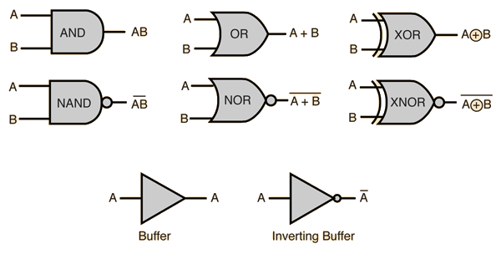

III B.TECH -I Semester (ECE)
A.Y 2018-2019

CERTIFICATE

This is to certify that this manual is a bonafide record of practical work in the Digital Integrated Circuits Applications for the First Semester of III year B. Tech (ECE) Programme during the academic year 2018-19. This book is prepared by Mr. J Narendar (Asst.Professor), Mr. J. Uma Maheshwar(Asst.Professor), Mr.B.N.Srinivas(Assoc.Professor), Mr V.Koteshwar Rao(Asst.Professor), Department of Electronics &Communications Engineering.

INDEX

SL.NO. | EXPERIMENT NAME | PAGENO.
 | Certificate | 2
 | Index | 3
 | Preface | 4
 | Acknowledgement | 5
 | Instructions to the Students | 6
 | Institution Vision & Mission | 7
 | Department Institution Vision & Mission | 8
 | Programme Outcomes | 9
 | Course Objectives& Course Outcomes | 10
 | List of Experiements | 11
1 | Design a 16 x 4 priority encoder using two 8 x 3 priority encoder. | 12
2 | Design a 16 bit comparator using 4 bit Comparators. | 17
3 | Design a modulo n counter using two decade counters. | 22
4 | Design a 450 KHz clock using NAND / NOR gates. | 27
5 | Design a 4 bit pseudo random sequence generator using 4 – bit ring counter. | 31
6 | Design a 16 x 1 multiplexer using 8 x 1 multiplexer. | 35
7 | Design a 16 bit Adder / Subtractor using 4 – bit Adder / Subtractor IC’s | 40
8 | Plot the transform Characteristics of 74H, LS, HS series IC’s. | 46
9 | Design a 4 – bit Gray to Binary and Binary to Gray Converter. | 51
10 | Design a two Digit 7 segment display | 57
11 | Design an 8 bit parallel load and serial out shift register using two 4 bit shift Register. | 64
12 | Design an 8 bit Serial in and serial out shift register using two 4 bit shift register. | 69
13 | Design a Ring counter and Twisted ring counter using a 4-bit shift register | 76

PREFACE

This book “Digital IC Applications” lab manual is intended to teach the design and analysis of basic digital circuits like MUX, Encoder, Counters, Shift Registers. We hope that this practical manual will be helpful for sand extending the concept to designing with 4 bit and 8 bit circuits. It helps to the students of Electronics &Communication Engineering for doing major project in the VLSI domain. There is always scope for improvement in the manual. We would appreciate to receive valuable suggestions from readers and users for future use.

By,
J Narendar,
J.Uma Maheshwar,
B.N.srinivas,
V.Koteshwar Rao.

ACKNOWLEDGEMENT

It was really a good experience, working with Digital IC Applications lab. First we would like to thank Mr.K.N.Bhushan, Assoc.Professor, HOD of Department of Electronics &Communications Engineering, Marri Laxman Reddy Institute of technology & Management for his concern and giving the technical support in preparing the document.

We are deeply indebted and gratefully acknowledge the constant support and valuable patronage of Dr.R.Kotaih, Director, Marri Laxman Reddy Institute of technology & Management for giving us this wonderful opportunity for preparing the Digital IC Applications laboratory manual.
We express our hearty thanks to Dr.K.Venkateswara Reddy, Principal, Marri Laxman Reddy Institute of technology & Management, for timely corrections and scholarly guidance.

At last, but not the least I would like to thanks the entire ECEE Department faculties those who had inspired and helped us to achieve our goal.

By,
J Narendar,
J.Uma Maheshwar,
B.N.srinivas,
V.Koteshwar Rao.

, Quthbullapur (M), Hyderabad-500043.

Department of Electronics & Communication Engineering

INSTRUCTIONS TO THE STUDENT FJHINSTRUCTIONS TO THE STUDENT

S TO THE STUDENT

- Students are required to attend all labs.

- Students will work individually in hardware laboratories and in computer laboratories.

- While coming to the lab bring the lab manual cum observation book, record etc.

- Take only the lab manual, calculator (if needed) and a pen or pencil to the work area.

- Before coming to the lab, prepare the pre-lab VIVA QUESTIONS. Read through the lab experiment to familiarize yourself with the components and assembly sequence.

- Utilize 3 hours time properly to perform the experiment (both in software and hardware) and note down the readings properly. Do the calculations, draw the graph and take signature from the instructor.

- If the experiment is not completed in the prescribed time, the pending work has to be done in the leisure hour or extended hours.

- You have to submit the completed record book according to the deadlines set up by your instructor.

- For practical subjects there shall be a continuous evaluation during the semester for 25 sessional marks and 50 end examination marks.

- Of the 25 marks for internal, 15 marks shall be awarded for day-to-day work and 10 marks to be awarded by conducting an internal laboratory test.

, Quthbullapur (M), Hyderabad-500043.

Department of Electronics & Communication Engineering

VISION AND MISSION OF THE INSTITUTE

INSTITUTE VISION:

To establish as an ideal academic institutions in the service of the nation, the world and the humanity by graduating talented engineers to be ethically strong, globally competent by conducting high quality research, developing breakthrough technologies, and disseminating and preserving technical knowledge.

INSTITUTE MISSION:
To fulfill the promised vision through the following strategic characteristics and aspirations:
- An atmosphere that facilitates personal commitment to the educational success of students in an environment that values diversity and community.
- Prudent and accountable resource management;
- Undergraduate programs that integrate global awareness, communication skills and team building across the curriculum;
- Leadership and service to meet society’s needs;
- Education and research partnerships with colleges, universities, and industries to graduate education and training that prepares students for interdisciplinary engineering research and advanced problem solving;
- Highly successful alumni who contribute to the profession in the global society.

, Quthbullapur (M), Hyderabad-500043.

Department of Electronics & Communication Engineering

VISION AND MISSION OF THE DEPARTMENT

DEPARTMENT VISION:

Imparting quality technical education through research, innovation and team work for a lasting technology development in the area of Electronics and Communication Engineering.

MISSION:

To develop a strong centre of excellence for education and research with excellent infrastructure and well qualified faculties to instill in them a passion for knowledge.

To achieve the Mission the department will
- Establish a unique learning environment to enable the students to face the challenges of the Electronics and Communication Engineering field.
- Promote the establishment of centre of excellence in niche technology areas to nurture the spirit of innovation and creativity among faculty and students.
- Provide ethical and value based education by promoting activities addressing the societal needs.
- Enable students to develop skills to solve complex technological problems of current times and also provide a framework for promoting collaborative and multidisciplinary activities.
PROGRAMME EDUCATIONAL OBJECTIVES
- PEO 1: have successful careers in Industry.
- PEO 2: show excellence in higher studies/ Research.
- PEO 3: Show good competency towards Entrepreneurship.

, Quthbullapur (M), Hyderabad-500043.

Department of Electronics & Communication Engineering

PROGRAM OUTCOMES
a | An ability to apply knowledge of Science, Mathematics, Engineering & Computing fundamentals for the solutions of Complex Engineering problems
b | An ability to identify, formulates, research literature and analyze complex engineering problems using first principles of mathematics and engineering sciences.
c | An ability to design solutions to complex process or program to meet desired needs.
d | Ability to use research-based knowledge and research methods including design of experiments to provide valid conclusions.
e | An ability to use appropriate techniques, skills and tools necessary for computing practice.
f | Ability to apply reasoning informed by the contextual knowledge to assess social issues, consequences & responsibilities relevant to the professional engineering practice.
g | Ability to understand the impact of engineering solutions in a global, economic, environmental, and societal context with sustainability.
h | An understanding of professional, ethical, Social issues and responsibilities.
i | An ability to function as an individual, and as a member or leader in diverse teams and in multidisciplinary settings.
j | An ability to communicate effectively on complex engineering activities within the engineering community.
k | Ability to demonstrate and understanding of the engineering and management principles as a member and leader in a team.
l | Ability to engage in independent and lifelong learning in the context of technological change.

PROGRAM SPECIFIC OUTCOMES
PSO1 | Analyze and design analog & digital circuits or systems for a given specification and function.
PSO2 | Implement functional blocks of hardware-software co-designs for signal processing and communication applications.

, Quthbullapur (M), Hyderabad-500043.

Department of Electronics & Communication Engineering

COURSE OBJECTIVES:
1. To introduce the concepts of waveform generation and introduce some special function ICs.
2. To understand and implement the working of basic digital circuits

COURSE OUTCOMES:
On completion of this course, the students will have:
1. Understanding of the different families of digital integrated circuits and their characteristics.
2. Also students will be able to design circuits using operational amplifiers for various applications

, Quthbullapur (M), Hyderabad-500043.

Department of Electronics & Communication Engineering

DIGITAL IC APPLICATIONS LAB

- Design a 16 x 4 priority encoder using two 8 x 3 priority encoder.

- Design a 16 bit comparator using 4 bit Comparators.

- Design a modulo n counter using two decade counters.

- Design a 450 KHz clock using NAND / NOR gates.

- Design a 4 bit pseudo random sequence generator using 4 – bit ring counter.

- Design a 16 x 1 multiplexer using 8 x 1 multiplexer.

- Design a 16 bit Adder / Subtractor using 4 – bit Adder / Subtractor IC’s

- Plot the transform Characteristics of 74H, LS, HS series IC’s.

- Design a 4 – bit Gray to Binary and Binary to Gray Converter.

- Design a two Digit 7 segment display unit using this display the Mod counter output of experiment 3.
- Design an 8 bit parallel load and serial out shift register using two 4 bit shift register.

- Design an 8 bit Serial in and serial out shift register using two 4 bit shift register.

- Design a Ring counter and Twisted ring counter using a 4-bit shift register

EXPERIMENT-1
16x4 PRIORITY ENCODER USING TWO 8x3 PRIORITY ENCODERS
AIM:
To verify the truth table of 16x4 priority encoder using Two 8x3 priority encoder.

APPARATUS:
- 16x4 priority encoder using Two 8x3 priority encoder.
- Connecting Wires.

THEORY:
Sometimes you have more inputs than can be used with a single encoder chip. For instance, if you have 16 inputs but your encoder chip only takes 8 or 10. In that case, you want to cascade the encoder chips so that instead of having two sets of three bit outputs, you have a single four bit output.
You can use the 74148 IC as the encoder in this case. It has a few additional inputs and outputs compared to the 74147. Some of these extra pins are what allow these devices to be cascaded.
Below is the schematic for how to cascade two 74148s to give a single 4 bit output. Note that while the inputs are active low, the outputs are active high.

PIN CONFIGURATION:
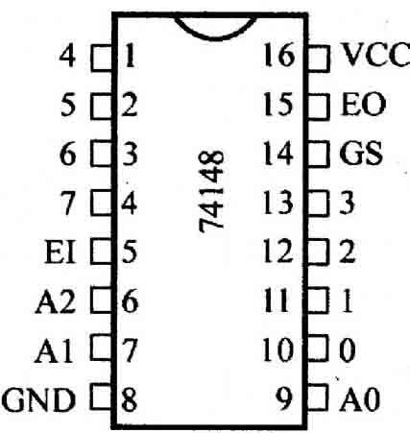

CIRCUIT DIAGRAM:

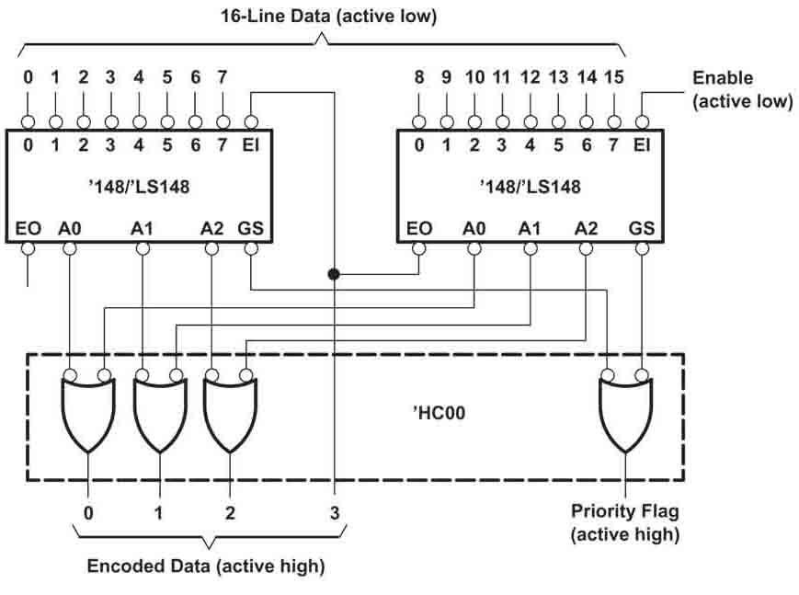

PROCEDURE:
- Connect the circuit as per circuit diagram.
- Connect the inputs as shown in Truth Table to the logic switches provided.
- Connect the outputs to the LED’s provided on the trainer board.
- Switch ON the trainer kit.
- Note down the output and compare with truth table.

TRUTH TABLE:

Active High:

 |  |  |  |  |  |  |  | INPUTS |  |  |  |  |  |  |  |  |  |  | OUTPUT
E1 | 0 | 1 | 2 | 3 | 4 | 5 | 6 | 7 | 8 | 9 | 10 | 11 | 12 | 13 | 14 | 15 | 16 | GS | A0 | A1 | A2 | E0
H | X | X | X | X | X | X | X | X | X | X | X | X | X | X | X | X | X | H | H | H | H | H
L | H | H | H | H | H | H | H | H | H | H | H | H | H | H | H | H | H | H | H | H | H | L
L | X | X | X | X | X | X | X | X | X | X | X | X | X | X | X | X | L | L | L | L | L | H
L | X | X | X | X | X | X | X | X | X | X | X | X | X | X | X | L | H | L | H | L | L | H
L | X | X | X | X | X | X | X | X | X | X | X | X | X | X | L | H | H | L | L | H | L | H
L | X | X | X | X | X | X | X | X | X | X | X | X | X | L | H | H | H | L | H | H | L | H
L | X | X | X | X | X | X | X | X | X | X | X | X | L | H | H | H | H | L | L | L | H | H
L | X | X | X | X | X | X | X | X | X | X | X | L | H | H | H | H | H | L | H | L | H | H
L | X | X | X | X | X | X | X | X | X | X | L | H | H | H | H | H | H | L | L | H | H | H
L | L | H | H | H | H | H | H | H | H | H | H | H | H | H | H | H | H | L | H | H | H | H

Active Low

 |  |  |  |  |  |  |  | INPUTS |  |  |  |  |  |  |  |  |  | OUTPUT (Active Low)
E1 | 0 | 1 | 2 | 3 | 4 | 5 | 6 | 7 | 8 | 9 | 10 | 11 | 12 | 13 | 14 | 15 | 16 | GS | A0 | A1 | A2 | E0
L | X | X | X | X | X | X | X | X | X | X | X | X | X | X | X | X | X | L | L | L | L | L
H | L | L | L | L | L | L | L | L | L | L | L | L | L | L | L | L | L | L | L | L | L | H
H | X | X | X | X | X | X | X | X | X | X | X | X | X | X | X | X | H | H | H | H | H | L
H | X | X | X | X | X | X | X | X | X | X | X | X | X | X | X | H | L | H | L | H | H | L
H | X | X | X | X | X | X | X | X | X | X | X | X | X | X | H | L | L | H | H | L | H | L
H | X | X | X | X | X | X | X | X | X | X | X | X | X | H | L | L | L | H | L | L | H | L
H | X | X | X | X | X | X | X | X | X | X | X | X | H | L | L | L | L | H | H | H | L | L
H | X | X | X | X | X | X | X | X | X | X | X | H | L | L | L | L | L | H | L | H | L | L
H | X | X | X | X | X | X | X | X | X | X | H | L | L | L | L | L | L | H | H | L | L | L
H | H | L | L | L | L | L | L | L | L | L | L | L | L | L | L | L | L | H | L | L | L | L

RESULT:
The 16x4 prority encoder using two 8x3 priority encoder is designed , implemented and output is verified.

VIVA QUESTIONS:

1.What is encoder?
2. What does Priority encoder mean?
3. The most commonly priority system is based on what?
4.What are the applications of Priority encoder?
5.What is the difference between encoder and Priority encoder?
6.Name the digital IC Number that is used as Priority encoder?
7.What is importance of enable line in Encoder?
8. Can an encoder be called as multiplexer? Explain
9.What is the role of an encoder in communication?
10.What is the advantage of using an encoder?
11.What are the differences between half adder and full adder?
12. What are the advantages of minimizing the logical expressions?
13. What does a combinational circuit mean?
14.What is the difference between sequential and combinational circuit?
15.. What is a flip-flop?5. Explain the functions of preset and clear inputs in flip- flop?
16. What is meant by a clocked flip-flop?
17. What is meant by excitation table?
18. What is the difference between flip-flop and latch?
19. What are the various methods used for triggering flip-flops?
20. Explain level triggered flip-flop?
21Explain the operation of IC74X93?
22. Write the syntax for component instantiation?
23. What is netlist?
24. Briefly explain about generics?
25. Write the difference between sequential statement and concurrent statement?
26. Write the syntax for loop statements?
27. Write the syntax for generate statements?
28. Write the differences between loop and generate?
29.What does priority encoder mean?7.
30.How many decoders are needed to construct 4X16 decoder?
31. What is the difference between decoder and encoder?
32. Write the syntax for exit statement?
33. Explain briefly about next statement?
34. How to specify the delay in VHDL program?
35. Write the syntax for component declaration.
36.Write the behavioral code for IC 74x189 without declaring the function
37. Explain about different types of RAMs?
38. How to specify the memory size?
39. Explain read and write operations?
40. What are the differences between RAM and RAM?
41. Explain the steps of a compilation process of a VHDL program?
42. Explain the types of design units?
43. Why configurations are needed?
44. What is subprogram in vhdl
45.Write the behavioral code for the IC 74x74.
46. Write the dataflow code for the IC 74x74.
47. What is the difference between sequential and combinational circuit?
48. What is a flip-flop?5. Explain the functions of preset and clear inputs in flip-flop?
49. What is meant by a clocked flip-flop?
50. What is meant by excitation table?

EXPERIMENT-2
16-BIT COMPARATOR USING 4 BIT COMPARATORS

AIM:
To construct and verify a 16 Bit Comparator using 4 Bit Comparators.

APPARATUS:
- 16 Bit comparator using 4 Bit comparator trainer kit.
- Patch cords.

THEORY:
Data comparison is needed in digital systems while performing arithmetic or logical operations. This comparison determines whether one number is greater than, equal, or less than the other number. A digital comparator is widely used in combinational system and is specially designed to compare the relative magnitudes of binary numbers. These are also available in IC form with different bit comparing configurations such as 4-bit, 8-bit, etc. More than one comparator can also be connected in cascade arrangement to perform comparison of numbers of longer lengths. Whenever we want to compare the two binary numbers, first we have to compare the most significant bits. If these MSBs are equal, then only we need to compare the next significant bits. But if the MSBs are not equal, then it would be clear that either A is greater than or less than B and the process of comparison ceases. For example, the two 2-bit number are A = A1A0 and B=B1B0. If A1 is not equal to B1, then it is clear that A is greater than B for A1 =1 & B1= 0 or else A is less than B for A0= 0 & B0 =1. At this stage the process of comparison ceases. If the MSBs are equal, i.e., A1=B1 only then we need to compare the next significant bits A0 and B0 and decide whether the number is greater than, less than or equal. So, the comparator produces three outputs as L, E and G corresponds to less than, equal and greater than comparisons. A magnitude digital comparator is a combinational circuit that compares two digital or binary numbers (consider A and B) and determines their relative magnitudes in order to find out whether one number is equal, less than or greater than the other digital number. Three binary variables are used to indicate the outcome of the comparison as A>B, A<B, or A=B. The below figure shows the block diagram of a n-bit comparator which compares the two numbers of n-bit length and generates their relation between themselves. These comparators can compare 2-bit, 4-bit and 8-bit numbers depending on the application requirement.

PIN CONFIGURATION:

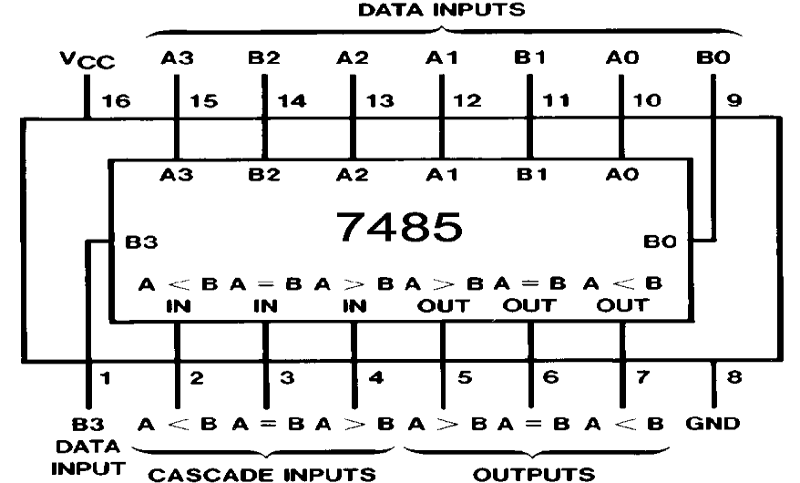

CIRCUIT DIAGRAM:

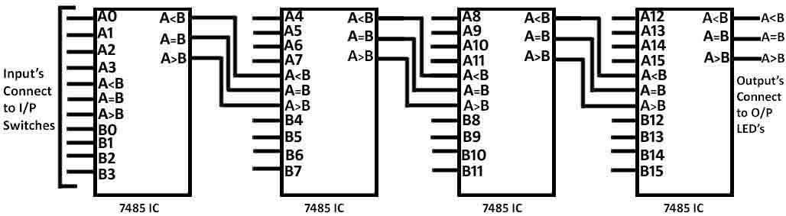

PROCEDURE:
  - Connect the circuit as shown in circuit Diagram.
  - Connect the Comparing Inputs to the Input switches, which are present on the trainer kit.
  - Connect the Cascading Inputs to the Input switches, which are present on the trainer kit.
  - Connect Outputs to the LED’s.
  - Observe output and verify with the truth table as given below.

TRUTH TABLE:
NOTE: Connect Cascading Inputs to the Input switches and apply the condition for all below given table
A<B – L, A=B – H, A>B – L.

COMPARING INPUTS A0 to A15 |  |  |  |  |  |  |  |  |  |  |  |  |  |  |  | COMPARING INPUTS B0 to B15 |  |  |  |  |  |  |  |  |  |  |  |  |  |  |  | OUTPUTS
A  0 | A  1 | A  2 | A  3 | A  4 | A  5 | A  6 | A  7 | A  8 | A  9 | A  1  0 | A  1  1 | A  1  2 | A  1  3 | A  1  4 | A  1  5 | B  0 | B  1 | B  2 | B  3 | B  4 | B  5 | B  6 | B  7 | B  8 | B  9 | B  1  0 | B  1  1 | B  1  2 | B  1  3 | B  1  4 | B  1  5 | A  > B | A  = B | A  < B
0 | 0 | 0 | 0 | 0 | 0 | 0 | 0 | 0 | 0 | 0 | 0 | 0 | 0 | 0 | 0 | 0 | 0 | 0 | 0 | 0 | 0 | 0 | 0 | 0 | 0 | 0 | 0 | 0 | 0 | 0 | 0 | 0 | 1 | 0
0 | 0 | 0 | 0 | 0 | 0 | 0 | 0 | 0 | 0 | 0 | 0 | 0 | 0 | 0 | 0 | 1 | 0 | 0 | 0 | 0 | 0 | 0 | 0 | 0 | 0 | 0 | 0 | 0 | 0 | 0 | 0 | 0 | 0 | 1
0 | 0 | 0 | 0 | 0 | 0 | 0 | 0 | 0 | 0 | 0 | 0 | 0 | 0 | 0 | 0 | 0 | 1 | 0 | 0 | 0 | 0 | 0 | 0 | 0 | 0 | 0 | 0 | 0 | 0 | 0 | 0 | 0 | 0 | 1
0 | 0 | 0 | 0 | 0 | 0 | 0 | 0 | 0 | 0 | 0 | 0 | 0 | 0 | 0 | 0 | 1 | 1 | 0 | 0 | 0 | 0 | 0 | 0 | 0 | 0 | 0 | 0 | 0 | 0 | 0 | 0 | 0 | 0 | 1
1 | 0 | 0 | 0 | 0 | 0 | 0 | 0 | 0 | 0 | 0 | 0 | 0 | 0 | 0 | 0 | 0 | 0 | 0 | 0 | 0 | 0 | 0 | 0 | 0 | 0 | 0 | 0 | 0 | 0 | 0 | 0 | 1 | 0 | 0
1 | 0 | 0 | 0 | 0 | 0 | 0 | 0 | 0 | 0 | 0 | 0 | 0 | 0 | 0 | 0 | 1 | 0 | 0 | 0 | 0 | 0 | 0 | 0 | 0 | 0 | 0 | 0 | 0 | 0 | 0 | 0 | 0 | 1 | 0
1 | 0 | 0 | 0 | 0 | 0 | 0 | 0 | 0 | 0 | 0 | 0 | 0 | 0 | 0 | 0 | 0 | 1 | 0 | 0 | 0 | 0 | 0 | 0 | 0 | 0 | 0 | 0 | 0 | 0 | 0 | 0 | 0 | 0 | 1
1 | 0 | 0 | 0 | 0 | 0 | 0 | 0 | 0 | 0 | 0 | 0 | 0 | 0 | 0 | 0 | 1 | 1 | 0 | 0 | 0 | 0 | 0 | 0 | 0 | 0 | 0 | 0 | 0 | 0 | 0 | 0 | 0 | 0 | 1
0 | 1 | 0 | 0 | 0 | 0 | 0 | 0 | 0 | 0 | 0 | 0 | 0 | 0 | 0 | 0 | 0 | 0 | 0 | 0 | 0 | 0 | 0 | 0 | 0 | 0 | 0 | 0 | 0 | 0 | 0 | 0 | 1 | 0 | 0
0 | 1 | 0 | 0 | 0 | 0 | 0 | 0 | 0 | 0 | 0 | 0 | 0 | 0 | 0 | 0 | 1 | 0 | 0 | 0 | 0 | 0 | 0 | 0 | 0 | 0 | 0 | 0 | 0 | 0 | 0 | 0 | 1 | 0 | 0
0 | 1 | 0 | 0 | 0 | 0 | 0 | 0 | 0 | 0 | 0 | 0 | 0 | 0 | 0 | 0 | 0 | 1 | 0 | 0 | 0 | 0 | 0 | 0 | 0 | 0 | 0 | 0 | 0 | 0 | 0 | 0 | 0 | 1 | 0
0 | 1 | 0 | 0 | 0 | 0 | 0 | 0 | 0 | 0 | 0 | 0 | 0 | 0 | 0 | 0 | 1 | 1 | 0 | 0 | 0 | 0 | 0 | 0 | 0 | 0 | 0 | 0 | 0 | 0 | 0 | 0 | 0 | 0 | 1
1 | 1 | 0 | 0 | 0 | 0 | 0 | 0 | 0 | 0 | 0 | 0 | 0 | 0 | 0 | 0 | 0 | 0 | 0 | 0 | 0 | 0 | 0 | 0 | 0 | 0 | 0 | 0 | 0 | 0 | 0 | 0 | 1 | 0 | 0
1 | 1 | 0 | 0 | 0 | 0 | 0 | 0 | 0 | 0 | 0 | 0 | 0 | 0 | 0 | 0 | 1 | 0 | 0 | 0 | 0 | 0 | 0 | 0 | 0 | 0 | 0 | 0 | 0 | 0 | 0 | 0 | 1 | 0 | 0
1 | 1 | 0 | 0 | 0 | 0 | 0 | 0 | 0 | 0 | 0 | 0 | 0 | 0 | 0 | 0 | 0 | 1 | 0 | 0 | 0 | 0 | 0 | 0 | 0 | 0 | 0 | 0 | 0 | 0 | 0 | 0 | 1 | 0 | 0
1 | 1 | 0 | 0 | 0 | 0 | 0 | 0 | 0 | 0 | 0 | 0 | 0 | 0 | 0 | 0 | 1 | 1 | 0 | 0 | 0 | 0 | 0 | 0 | 0 | 0 | 0 | 0 | 0 | 0 | 0 | 0 | 0 | 1 | 0

RESULT:-

The 16 Bit Comparator using 4 Bit Comparators was designed and implemented.

VIVA QUESTIONS:

- What is Magnitude Comparator?
- List out the applications of comparators?
- What is digital comparator?
- Realize a single bit comparator?
- Which logic gate is a basic comparator?
- When are two numbers are equal?
- What are the different types of comparator?
- What are the advantages of comparator?
- If two numbers are not equal then binary variable will be
- A procedure that specifies finite set of steps is called ?
11.How many 4-bit comparators are needed to construct 12-bit comparator?
12. What does a digital comparator mean?
13. Design a 2-bit comparator using gates?
14. Explain the phases of a simulation?
15. Explain briefly about wait statement?
16.What do you mean by Logic Gates?
17.What are the applications of Logic Gates?
18.What is Truth Table?
19. Why we use basic logic gates?
20.Write down the truth table of all logic gates?
21.What do you mean by universal gate?
22.Write truth table for 2 input NOR,NAND gate?
23. Implement all logic gate by using universal gate?
24.Why is they called universal Gates?
25. Give the name of universal gate?
26. Draw the circuit diagram of Half adder circuit?
27.Draw the circuit diagram of full adder circuit?
28 Draw the full adder circuit by using Half Adder circuit and minimum no. of logicgate?
29.Write Boolean function for half adder?
30. Write Boolean function for Full adder?
31.Design the half Adder and Full adder using NAND-NAND Logic.
32. Draw the circuit diagram of Half Subtractor circuit?
33.Draw the circuit diagram of full subtractor circuit?
34.Draw the full subtractor circuit by using half subtractor circuit and minimum no. of logic gate?
35. Write Boolean function for half 7ubtractor?
36.Write Boolean function for Full Subtractor?
37. What is Excess-3 code? Why it is called Excess-3 code?
38.What is the application of Excess-3 code?
39. What is ASCII code?
40. Excess-3 code is Weighted or Unweighted?
41.Out of the possible 16 code combination? How many numbers used in Excess-3 code?
42.Which logic gate is a basic comparator?
43.When are two numbers are equal?
44.What are the different types of comparator?
45.What are the advantages of comparator?
46.If two numbers are not equal then binary variable will be
47.A procedure that specifies finite set of steps is called
48.How many 4-bit comparators are needed to construct 12-bit comparator?
49. What does a digital comparator mean?
50. Design a 4-bit comparator using gates?

EXPERIMENT-3
MODULO N COUNTER USING TWO DIGIT DISPLAY
AIM:
To construct the Modulo 53 counter using Two decade counters with Two Digit Display

APPARATUS:
- Modulo 53 using Two decade counters with two digital displays.
- Patch Cards.

THEORY:
Counters which advance their sequence of numbers or states when activated by a clock input are said to operate in a “count up” mode. Likewise, counters which decrease their sequence of numbers or states when activated by a clock input are said to operate in both the UP and DOWN modes are called bidirectional counters.
Counters are sequential logic devices that are activated or triggered by an external timing pulse or clock signal. A counter can be constructed to operate as a synchronous circuit or as an asynchronous circuit. With synchronous counters, all the data bits change synchronously with the application of a clock signal. Whereas an asynchronous counter circuit is independent of the input clock so the data bits change state at different times one after the other.
Then counters are sequential logic devices that follow a predetermined sequence of counting states which are triggered by an external clock (CLK) signal. The number of states or counting sequences through which a particular counter advances before returning once again back to its original first state is called
the modulus (MOD). In other words, the modulus (or just modulo) is the number of states the counter counts and is the dividing number of the counter.
Modulus counters, or simply MOD counters, are defined based on the number of states that the counter will sequence through before returning back to its original value. For example, a 2-bit counter that counts from 002 to 112 in binary, that is 0 to 3 in decimal, has a modulus value of 4 ( 00 → 01 → 10 → 11 , return back to 00 ) so would therefore be called a modulo-4, or mod-4, counter. Note also that it has taken 4 clock pulses to get from 00 to 11.
As in this simple example there are only two bits, ( n = 2 ) then the maximum number of possible output states (maximum modulus) for the counter is: 2n = 22 or 4. However, counters can be designed to count to any number of 2n states in their sequence by cascading together multiple counting stages to produce a single modulus or MOD-N counter.
Therefore , a “Mod-N͟ “ counter will require “N” number of flip-flops connected together to count a single data bit while providing 2n different output states, (n is the number of bits). Note that N is always a whole integer value.
The we can see that MOD counters have a modulus value that is an integral power of 2, that is, 2, 4, 8, 16 and so on to produce an n-bit counter depending on the number of flip-flops used, and how they are connected, determining the type and modulus of the counter

PIN CONFIGURATION:

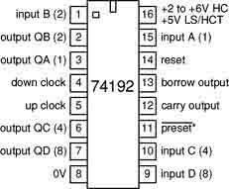
CIRCUIT DIAGRAM:

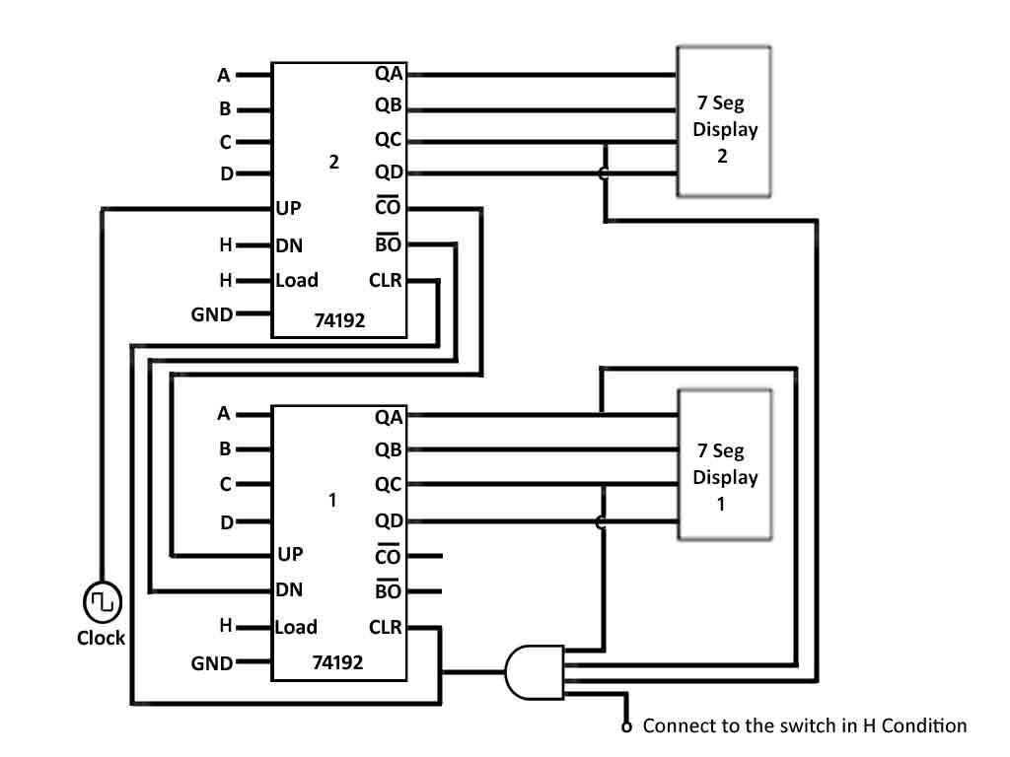

PROCEDURE:
- Connect circuit as per circuit diagram.
- Connect UP to the Clock as shown in circuit diagram.
- Connect QA, QB, QC, and QD to the 7 Segment displays which are provided on the trainer board.
- Connect Co to the UP terminal of another IC as shown in circuit diagram.
- Connect Bo to the DN terminal of another IC as given above.
- Connect CLR1 to the CLR2 as shown in the circuit.
- Connect QC1 to the AND Gate 3rd terminal.
- Connect QC1 to the AND Gate 3rd terminal.
- Connect QA2 to the AND Gate 2nd terminal.
- Connect QC2 to the AND Gate 1st terminal.
- Connect the AND Gate 4th terminal to the iŶput sǁitĐh, ǁhiĐh should iŶ ͞High͟.
- Observe the Modulo 53 count in the two 7 segment displays provided on the trainer kit.

Result

The Modulo 53 counter using Two decade counters with Two Digit Display was constructed.

VIVA QUESTIONS:

1.What is counter?
2.A counter circuit is usually constructed of what?
3.What is the maximum possible range of bit-count specifically in n-bit binary counter consisting of ‘n’ number of flip-flops?
4.How many types of counter are?
5.Ripple counters are also called....
6.What is the difference between combinational logic and sequential logic?
7.What is an asynchronous counter?
8. How is it different from a synchronous counter?
9.What are synchronous counters?
10.What is an excitation table?
11.This set of Digital Electronics/Circuits Multiple Choice VIVA QUESTIONS & Answers (MCQs) focuses on “Counters”.
12. A counter circuit is usually constructed of
13. What is the maximum possible range of bit-count specifically in n-bit binary counter consisting of ‘n’ number of flip-flops?
14. How many types of counter are?
15. A decimal counter has ______ states.
16. Ripple counters are also called..........
17. Synchronous counter is a type of.....
18. Three decade counter would have........
19. BCD counter is also known as......
20. The parallel outputs of a counter circuit represent the....
21.What advantages do synchronous counters have over asynchronous counters?
22.The combinational element of a counter can be made with...
23.What types of flip-flops can be used to implement the memory elements of a counter?
24.What are the advantages of using a microprocessor to implement a counter rather than the conventional method (flip-flop and logic gates)?
25.What is the principal advantage of Gray Code over straight (conventional) binary?
26.What is a multiplexer?
27Which combinational circuit is renowned for selecting a single input from multiple inputs & directing the binary information to output line?
28. Which is the major functioning responsibility of the multiplexing combinational circuit?
29.How many select lines would be required for an 8-line-to-1-line multiplexer?
30.How many NOT gates are required for the construction of a 4-to-1 multiplexer?
31.What are the applications of multiplexer and de-multiplexer?
32.In 2n to 1 multiplexer how many selection lines are there?
33.How to get higher order multiplexers?
34.Implement an 8:1 mux using 4:1 muxes
35.What is the difference between multiplexer & demultiplexer?
36.Define Ring counter?
37.By adding recirculating lines to a 4-bit parallel-in serial-out shift register, it becomes a ________, ________, and ________out register.
38.What type of register would have a complete binary number shifted in one bit at a time and have all the stored bits shifted out one at a time?
39.Define shift registers?
40.List the different types of shift registers?
41.What is Magnitude Comparator?
42.List out the applications of comparators?
43What is digital comparator?
44.Realize a single bit comparator?
44.Which logic gate is a basic comparator?
45.When are two numbers are equal?
46.What are the different types of comparator?
47.What are the advantages of comparator?
48.If two numbers are not equal then binary variable will be
49.A procedure that specifies finite set of steps is called
50.What are synchronous counters?

EXPERIMENT-4
A 450KHz CLOCK USING NAND/NOR GATES
AIM:
To study the Clock Generation by using NAND Gate and NOR Gate.

APPARATUS:
- Clock Generator using NAND/NOR Gates Trainer kit
- Patch Cords

THEORY:
Schmitt Waveform Generators can also be made using standard CMOS Logic NAND/NOR Gates connected to produce an inverter circuit. Here, two NAND/NOR gates are connected together to produce another type of RC relaxation oscillator circuit that will generate a square wave shaped output waveform as shown in the circuit diagram.

In this type of waveform generator circuit, the RC network is formed from resistor, R1 and the capacitor, C with this RC network being controlled by the output of the first NAND/NOR gate. The output from this R1C network is fed back to the input of the first NAND/NOR gate via resistor, R2 and when the charging voltage across the capacitor reaches the upper threshold level of the first NAND/NOR gate, the NAND/NOR gate changes state causing the second NAND/NOR gate to follow it, thereby change state and producing a change in the output level.
The voltage across the R1C network is now reversed and the capacitor begins to discharge through the resistor until it reaches the lower threshold level of the first NAND/NOR gate causing the two gates to change state once again. Like the previous Schmitt waveform generators circuit above, the frequency of oscillation is determined by the R1C time constant which is given as: 1/2.2R1C. Generally R2 is given a value that is 10 times the value of resistor R1.
When high stability or guaranteed self-starting is required, CMOS Waveform Generators can be made using three inverting NAND/NOR gates or any three logic inverters for that matter, connected together as shown below producing a circuit that is sometimes called “the ring of three” of three͟ wave form generator. The frequency of oscillation is determined again by the R1Ctime constant, the same as for the two gate oscillator above, and which is given as: 1/2.2R1C when R2 has a value that is 10 times the value of resistor, R1
The addition of the extra NAND/NOR gate guarantees that the oscillator will start even with very low capacitor values. Also the stability of the waveform generator is greatly improved as it is less susceptible to power supply variations due to its threshold triggering level being nearly half of the supply voltage.
The amount of stability is mainly determined by the frequency of oscillation and generally speaking, the lower the frequency the more stable the oscillator becomes.
As this type of waveform generator operates at nearly half or 50% of the supply voltage the resultant output waveform has very nearly a 50% duty cycle, 1:1 mark-space ratio. The three gate waveform generator has many advantages over the previous two gate oscillator above but it’s one big disadvantage is that it uses an additional logic gate.

CIRCUIT DIAGRAM:

NAND/NOR Gate Waveform Generator:

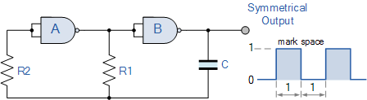

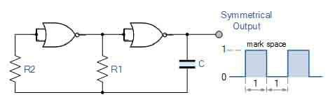

Stable NAND/NOR Gate Waveform Generator:

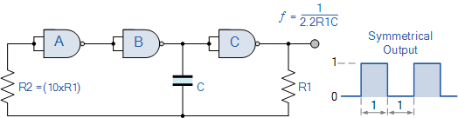

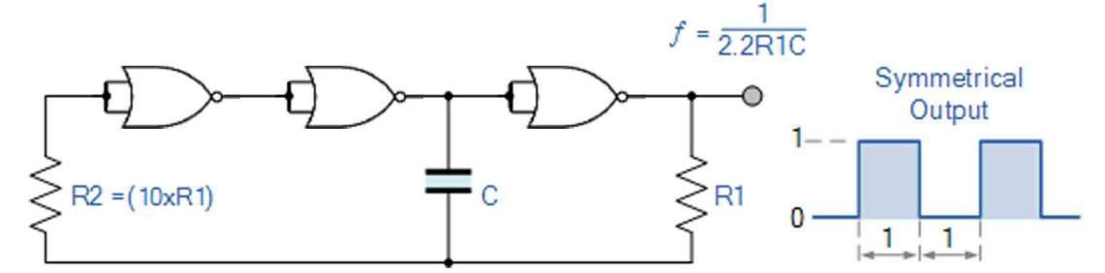

PROCEDURE:
- Switch ON the Clock Generator using NAND/NOR Gates trainer kit.
- Connect the any Resistor which are present on the trainer kit to R terminal in NAND/NOR Gate circuit.
- Connect the any Capacitor which are present on the trainer kit to C terminal in NAND/NOR Gate circuit.
- Connect CRO/DSO Channel 1 to the Clock O/P of NAND/NOR Gate.
- Observe the O/P wave form and Frequency by varying the Resistor (R) and Capacitor (C) Values

RESULT:
The Clock Generation by using NAND Gate and NOR Gate was studied.

VIVA QUESTIONS:

1. What are the universal gates? Why they are called so?
2. Realize the EX – OR gates using minimum number of NAND gates.
3. Give the truth table for EX-NOR and realize using NAND gates?
4. What are the logic low and High levels of TTL IC’s and CMOS IC’s?
5. Compare TTL logic family with CMOS family?
6 .Which logic family is fastest and which has low power dissipation?
7. What are the different methods to obtain minimal expression?
8.What is a Min term and Max term
9. State the difference between SOP and POS.
10. What is K-map? Why is it used?
11.What do you mean by Logic Gates?
12.What are the applications of Logic Gates?
13.What is Truth Table?
14. Why we use basic logic gates?
15.Write down the truth table of all logic gates?
16.What do you mean by universal gate?
17.Write truth table for 2 input NOR,NAND gate?
18. Implement all logic gate by using universal gate?
19.Why is they called universal Gates?
20. Give the name of universal gate?
21. Draw the circuit diagram of Half adder circuit?
22.Draw the circuit diagram of full adder circuit?
23 Draw the full adder circuit by using Half Adder circuit and minimum no. of logicgate?
24.Write Boolean function for half adder?
25. Write Boolean function for Full adder?261.Design the half Adder and Full adder using NAND-NAND Logic.
26.Pseudo Random Sequence Generator also known as what?
27.Ring counter belong to which type of counter?
28.What are the types of ring counter?
29. What is the difference between Johnson Ring Counter and synchronous ring counter?
30.What is meant by pseudorandom number generator?
31. List out the applications of PRNG.
32. TRNG stands for
33. Define Uniformity in PRNG
34. Define scalability.
35. Write the syntax for component declaration.
36. Write the behavioral code for IC 74x189 without declaring the function
37. Explain about different types of RAMs?
38. How to specify the memory size?
39. Explain read and write operations?
40. What are the differences between RAM and RAM?
41. Explain the steps of a compilation process of a VHDL program?
42. Explain the types of design units?
43. Why configurations are needed?
44. What is binding?10. What is subprogram in vhdl
45.Write the behavioral code for the IC 74x74.
46. Write the dataflow code for the IC 74x74.
47. What is the difference between sequential and combinational circuit?
48. What is a flip-flop? Explain the functions of preset and clear inputs in flip-flop?
49. What is meant by a clocked flip-flop?
50. What is meant by excitation table?

EXPERIMENT-5
4 BIT PSEUDO RANDOM SEQUENCE GENERATOR USING 4 BIT RING COUNTER

AIM:
To construct and study the Pseudo Random Sequence Generator using Ring Counter

APPARATUS:
- Pseudo Random Sequence Generator using Ring Counter trainer kit
- Patch Cords.

THEORY:
A pseudorandom number generator (PRNG), also known as a deterministic random bit generator (DRBG), is an algorithm for generating a sequence of numbers whose properties approximate the properties of sequences of random numbers. The PRNG-generated sequence is not truly random, because it is completely determined by an initial value, called the PRNG's seed (which may include truly random values). Although sequences that are closer to truly random can be generated using hardware random number generators, pseudorandom number generators are important in practice for their speed in number generation and their reproducibility.
PRNGs are central in applications such as simulations (e.g. for the Monte Carlo method), electronic games (e.g. for procedural generation), and cryptography. Cryptographic applications require the output not to be predictable from earlier outputs, and more elaborate algorithms, which do not inherit the linearity of simpler PRNGs, are needed.
Good statistical properties are a central requirement for the output of a PRNG. In general, careful mathematical analysis is required to have any confidence that a PRNG generates numbers that are sufficiently close to random to suit the intended use. John von Neumann cautioned about the misinterpretation of a PRNG as a truly random generator, and joked that "Anyone who considers arithmetical methods of producing random digits.

PIN CONFIGRATION:

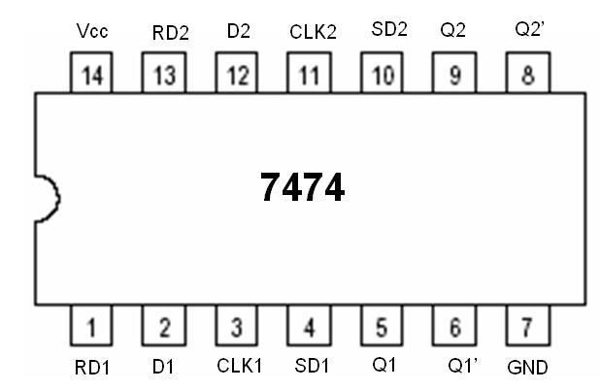

CIRCUIT DIAGRAM:

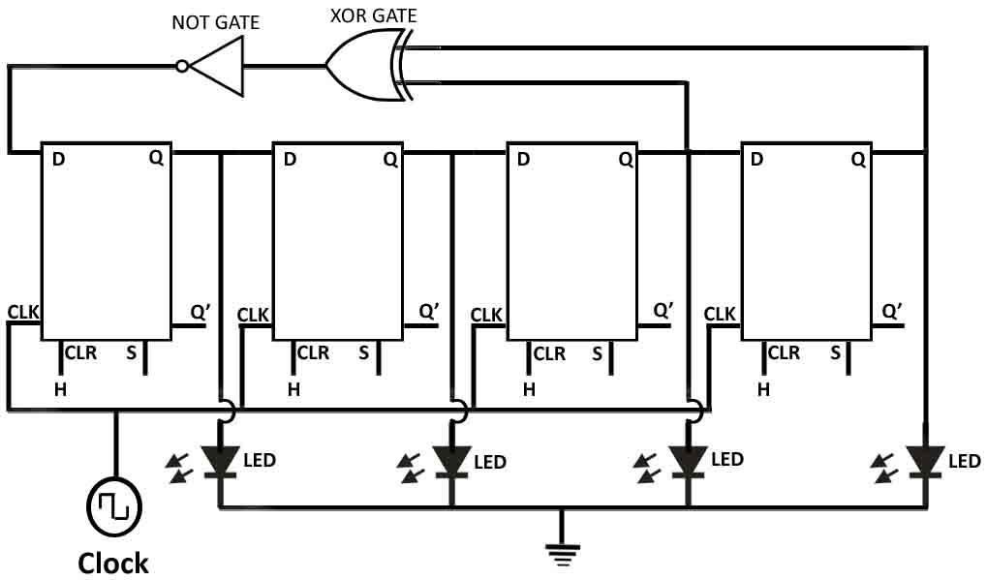

PROCEDURE:
- Connect the circuit as show in the circuit diagram.
- Connect the NOT Gate to the D terminal and another terminal to XOR Gate as shown above in the diagram.
- XOR Gate other to Q and LED and another terminal to Q and another LED as shown in above diagram.
- Connect the Q to D as shown in above circuit.
- Connect CLK O/P to CLK I/P terminals as shown.
- Connect the all CLR to the Input Switch.
- Observe the O/P which 4bit Pseudo random sequence using 4bit ring counter.

TRUTH TABLE:
D | QA | QB | QC | QD
1 | 0 | 0 | 0 | 0
1 | 1 | 0 | 0 | 0
1 | 1 | 1 | 0 | 0
0 | 1 | 1 | 1 | 0
1 | 0 | 1 | 1 | 1
1 | 1 | 0 | 1 | 1
0 | 1 | 1 | 0 | 1
0 | 0 | 1 | 1 | 0
1 | 0 | 0 | 1 | 1
0 | 1 | 0 | 0 | 1
1 | 0 | 1 | 0 | 0
0 | 1 | 0 | 1 | 0
0 | 0 | 1 | 0 | 1
0 | 0 | 0 | 1 | 0
0 | 0 | 0 | 0 | 1
1 | 0 | 0 | 0 | 0

RESULT:
The Pseudo Random Sequence Generator using Ring Counter was constructed and studied.

VIVA QUESTIONS:

- Pseudo Random Sequence Generator also known as what?
- Ring counter belong to which type of counter?
- What are the types of ring counter?
- What is the difference between Johnson Ring Counter and synchronous ring counter?
- What is meant by pseudorandom number generator?
- List out the applications of PRNG.
- TRNG stands for
- Define Uniformity in PRNG
- Define scalability.
- Why PRNGs are derived through algorithms.
- What are the differences between half adder and full adder?
- What are the advantages of minimizing the logical expressions?
- What does a combinational circuit mean?
- What is the difference between sequential and combinational circuit?
- What is a flip-flop?5. Explain the functions of preset and clear inputs in flip- flop?
- What is meant by a clocked flip-flop?
- What is meant by excitation table?
- What is the difference between flip-flop and latch?
- What are the various methods used for triggering flip-flops?
- Explain level triggered flip-flop?
- Explain the operation of IC74X93?
- Write the syntax for component instantiation?
- What is net list?
- Briefly explain about generics?
- Write the difference between sequential statement and concurrent statement?
- Write the syntax for loop statements?
- Write the syntax for generate statements?
- Write the differences between loop and generate?
- What does priority encoder mean?7.
- How many decoders are needed to construct 4X16 decoder?
- List out the applications of PRNG.
- TRNG stands for
- Define Uniformity in PRNG
- Define scalability.
- Write the syntax for component declaration.
- Write the behavioral code for IC 74x189 without declaring the function
- Explain about different types of RAMs?
- How to specify the memory size?
- Explain read and write operations
- List the different types of shift registers?
- What is Magnitude Comparator?
- List out the applications of comparators?
- What is digital comparator?
- Realize a single bit comparator?
- Which logic gate is a basic comparator?
- When are two numbers are equal?
- What are the different types of comparator?
- What are the advantages of comparator?
- If two numbers are not equal then binary variable will be
- What are synchronous counters?
EXPERIMENT-6
16x1 MULTIPLEXER USING TWO 8x1 MULTIPLEXERS

AIM:
To verify the truth table of 16x1 Multiplexer using Two 8x1 Multiplexer.

APPARATUS:
- 16x1 Multiplexer using Two 8x1 Multiplexer.
- Connecting Wires.

THEORY:
Multiplexer is one of the basic building units of a computer system which in principle allows sharing of a common line by more than one input lines. It connects multiple input lines to a single output line. At a specific time one of the input lines is selected and the selected input is passed on to the output line.
Relation between multiple Input lines and Selection lines
Input lines 16 = 24 i.e. 4 Selection lines Input lines will be I0 - I15

Selection lines will be S0 - S3

PIN CONFIGURATION:
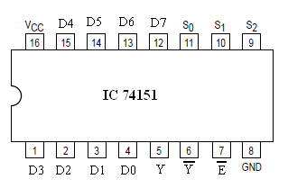

CIRCUIT DIAGRAM:
Circuit Diagram using Gates:

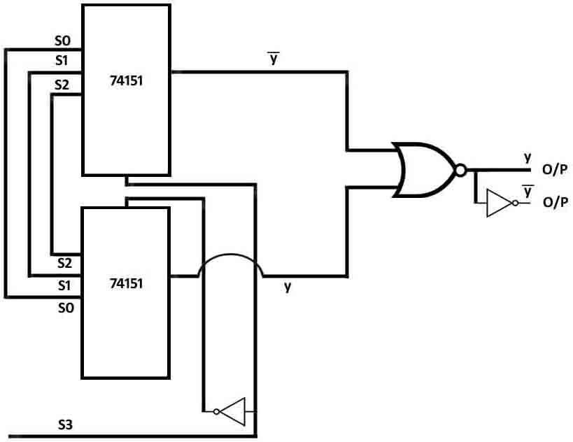

Circuit Diagram using IC 74157 (2x1Mux):

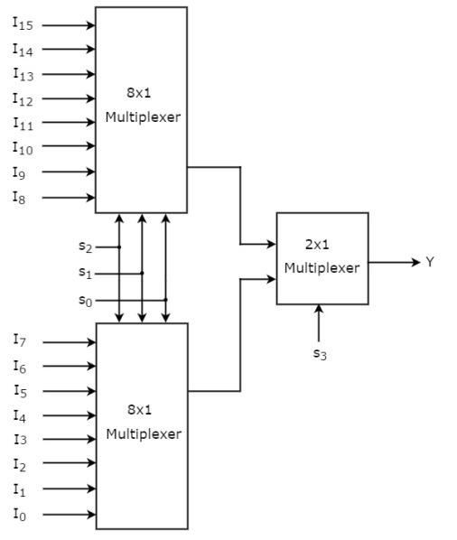

The diagram will be same as of the block diagram of 16-to-1 line multiplexer in which 8-to-1 line multiplexer Selection lines will be S0 - S2and S3will be connected to 2-to-1 line multiplexer Selection and First 8-to-1 line multiplexer Input lines will be I0 - I7and Second8-to-1 line multiplexer Input lines will be I8 - I15. Let us implement 16x1 Multiplexer using 8x1 Multiplexers and 2x1 Multiplexer. We know that 8x1 Multiplexer has 8 data inputs, 3 selection lines and one output. Whereas, 16x1 Multiplexer has 16 data inputs, 4 selection lines and one output. So, we require two 8x1 Multiplexers in first stage in order to get the 16 data inputs. Since, each 8x1 Multiplexer produces one output, we require a 2x1 Multiplexer in second stage by considering the outputs of first stage as inputs and to produce the final output.
Let the 16x1 Multiplexer has sixteen data inputs I15 to I0, four selection lines s3 to s0 and one output Y. The Truth table of 16x1 Multiplexer is shown below. The same selection lines, s2, s1 & s0 are applied to both 8x1 Multiplexers. The data inputs of upper 8x1 Multiplexer are I15 to I8 and the data inputs of lower 8x1 Multiplexer are I7 to I0. Therefore, each 8x1 Multiplexer produces an output based on the values of selection lines, s2, s1 & s0.The outputs of first stage 8x1 Multiplexers are applied as inputs of 2x1 Multiplexer that is present in second stage. The other selection line, s3 is applied to 2x1 Multiplexer.
- If s3 is zero, then the output of 2x1 Multiplexer will be one of the 8 inputs Is7 to I0 based on the values of selection lines s2, s1 & s0.
- If s3 is one, then the output of 2x1 Multiplexer will be one of the 8 inputs I15 to I8 based on the values of selection lines s2, s1 & s0. Therefore, the overall combination of two 8x1 Multiplexers and one 2x1 Multiplexer performs as one 16x1 Multiplexer.

PROCEDURE:
- Connect the input as shown in the Truth Table to the logic switches which are provided on the trainer board.
- Connect the output to the LED’s switch are provided on the trainer board.
- Connect the S3, S2, S1, S0 Inputs from the outputs provided on the trainer board.
- Switch ON the trainer kit.
- Note down the output and compare with the truth table.

TRUTH TABLE:

Selection Inputs |  |  |  | Output
S3 | S2 | S1 | S0 | Y
0 | 0 | 0 | 0 | I0
0 | 0 | 0 | 1 | I1
0 | 0 | 1 | 0 | I2
0 | 0 | 1 | 1 | I3
0 | 1 | 0 | 0 | I4
0 | 1 | 0 | 1 | I5
0 | 1 | 1 | 0 | I6
0 | 1 | 1 | 1 | I7
1 | 0 | 0 | 0 | I8
1 | 0 | 0 | 1 | I9
1 | 0 | 1 | 0 | I10
1 | 0 | 1 | 1 | I11
1 | 1 | 0 | 0 | I12
1 | 1 | 0 | 1 | I13
1 | 1 | 1 | 0 | I14
1 | 1 | 1 | 1 | I15

RESULT:
The truth table of 16x1 Multiplexer using Two 8x1 Multiplexer was verified.

VIVA QUESTIONS

- What is a multiplexer?
- Which combinational circuit is renowned for selecting a single input from multiple inputs & directing the binary information to output line?
- Which is the major functioning responsibility of the multiplexing combinational circuit?
- How many select lines would be required for an 8-line-to-1-line multiplexer?
- How many NOT gates are required for the construction of a 4-to-1 multiplexer?
- What are the applications of multiplexer and de-multiplexer?
- In 2n to 1 multiplexer how many selection lines are there?
- How to get higher order multiplexers?
- Implement an 8:1 mux using 4:1 muxes
- What is the difference between multiplexer & demultiplexer?
- Explain the operation of a digital multiplexer?
- What makes the circuit of a multiplexer more complex?
- What Is data selector?
- What is a multiplexer?
- Which mux without any additional circuitry can be used to obtain all the functions of 3 variable but not all of 4 variables?
- How many 2*1 mux are required to realize 4*1 mux and explain how?
- Design a 4*1 mux using 2*1 mux?
- What are the minimum number of 21 mux required to generate 2 input nandgate and a 2 input Ex-OR gate?
- How a multiplexer can act as a universal combinational circuit explain?
- Construct a NOT gate using 2*1 mux
- . Construct a AND gate using 2*1 mux
- Construct OR gate using 2*1 mux with n-1 selection lines
- Construct a NAND gate using 2*1 mux
- Construct a NOR gate using 2*1 mux
- Construct a Ex-OR gate using 2*1 mux
- Construct a Ex-NOR gate using 2*1 mux
- How many 2*1 mux are required for 8*1 mux construction?
- How many 2*1 mux are required for 16*1 mux construction?
- How many 2*1 mux are required for 64*1 mux construction?
- Obtain the logic for the construction of different multiplexers using 2*1 mux?
- How can you classify different digital multiplexers?
- What is synchronous multiplexer?
- What is asynchronous multiplexer?
- What is quasi-synchronous multiplexer?
- What are advantages of digital multiplexing?
- Will multiplexing create additional harmonics in the system?
- What are the two basic multiplexing techniques?
- Why are generally multiplexers are used?
- What is demultiplexer?
- What are the differences between multiplexer and demultiplexer?
- How to get higher order multiplexers?
- What are the different logic gates that are used in multiplexers.draw their symbols?
- What is data distributor?
- How many data inputs does a mux have?
- What are the components of a mux?
- What is a combinational circuit?
- Hat is the ic used in the design of 16*1 mux using two 8*1 mux?
- What is an integrated circuit?
- Draw the pin configuration of IC74151
- How many selectionlines are required for 8*1 mux?

EXPERIMENT-7
16 BIT ADDER/SUBTRACTOR USING 4 BITADDER/SUBTRACTOR

AIM:
To construct the 16 Bit Adder and Subtractor using 4 Bit Adders

APPARATUS:
- 16 Bit Adder and Subtractor using 4 Bit Adders trainer kit
- Patch Cords.

THEORY:
A Binary Subtractor is a decision making circuit that subtracts two binary numbers from each other, for example, X – Y to find the resulting difference between the two numbers. Unlike the Binary Adder which produces a SUM and a CARRY bit when two binary numbers are added together, the binary subtractor produces a DIFFERENCE, D by using a BORROW bit, B from the previous column. Then obviously, the operation of subtraction is the opposite to that of addition. We learnt from our maths lessons at school that the minus sign, - is used for a subtraction calculation, and when one number is subtracted from another, a borrow is required if the subtrahend is greater than the minuend. Consider the simple subtraction of the two denary (base 10) numbers below. We cannot directly subtract 8 from 3 in the first column as 8 is greater than 3, so we have to borrow a 10, the base number, from the next column and add it to the minuend to produce 13 minus 8. This “borrowed” 10 is then return back to the subtrahend of the next column once the difference is found .simple school maths, borrow a 10 if needed ,find the difference and return the borrow. The subtraction of one binary number from another is exactly the same idea as that for subtracting two decimal numbers but as the binary number system is a Base-2 numbering system which uses 0 and 1 as its two independendent digits ,large binary nos which are to be subtracted from each other are therefore represented in terms of 0’s and 1’s . Binary Subtraction can take many forms but the rules for subtraction are the same whichever process you use. As binary notation only has two digits, subtracting a 0 from a 0 are a 1 leads the result unchanged as 0-0 = 0 and 1-0 = 1. Subtracting a 1 from a 1 results in a 0,but subtracting a 1 from a 0 requires a borrow.In other words 0 – 1 equires a borrow. For the simple 1-bit subtraction problem above, if the borrow bit is ignored the result of their binary subtraction resembles that of an Exclusive-OR Gate. To prevent any confusion in this tutorial between a binary subtractor input labelled, B and the resulting borrow bit output from the binary subtractor also being labelled, B, we will label the two input bits as X for the minuend and Y for the subtrahend. Then the resulting truth table is the difference between the two input bits of a single binary subtractor. As with the binary adder ,the difference between the two digits is only a 1 when these two iinputs are not equal as given by the Ex-OR expression. However, we need an additional output to produce the borrow bit when input X = 0 and Y = 1. Unfortunately there are no standard logic gates that will produce an output for this particular combination of X and Y inputs. But we know that an AND Gate produces an output 1 when both of its inputs X and Y are 1(HIGH) so if we use an inverter or NOT Gate to complement the input X before it is fed to the AND gate, we can produce the required borrow output when X = 0 and Y = 1. If we wanted to use the 4-bit adder for addition once again, all we would need to do is set the carry-in Cin input low at logic 0 . Because we can use the 4-bit adder IC such as the 74LS83 or 74LS283 as a full-adder or a full-subtractor they are available as a single adder/subtractor circuit with a single control input for selecting between the two operations.

PIN CONFIGRATION:

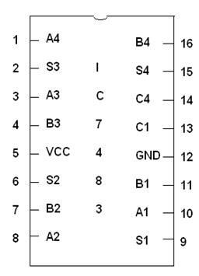

CIRCUIT DIAGRAM:
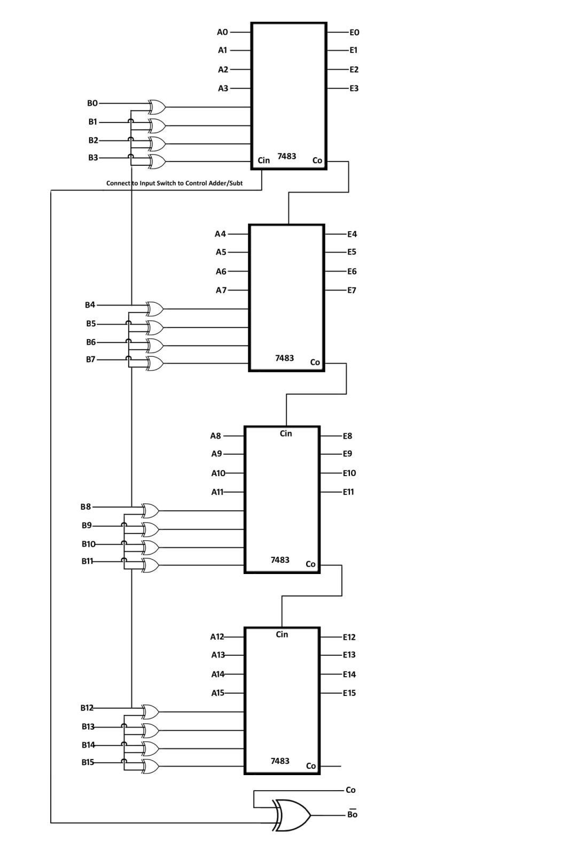

PROCEDURE:
  - Connect the circuit as per circuit diagram.
  - Connect A0, A1, A2, A3, A4, A5, A6, A7, A8, A9, A10, A11, A12, A13, A14, A15 to Input switches as provided on the trainer kit.
  - Connect B0, B1, B2, B3, B4, B5, B6, B7, B8, B9, B10, B11, B12, B13, B14, B15 to the X-OR Gates which are present on the trainer kit as shown above in the circuit diagram.
  - Connect Cin of first IC to another X-OR Gate as shown above and the it to Input switch as a controlling adder and subtractor as the input switch is in H condition then adder when the switch is in L condition then subtractor.
  - Connect the Outputs E0, E1, E2, E3, E4, E5, E6, E7, E8, E9, E10, E11, E12, E13, E14, E15, Co and Bo’ to the output LED’S which are provided on trainer kit .
  - Connect the Co of the second IC to C in as shown above.
  - Verify the Truth Table.

TRUTH TABLE:

16 Bit Adder:

INPUTS |  |  |  |  |  |  |  | OUTPUTS
A15 | A14-A2 | A1 | A0 | B15 | B15-B2 | B1 | B0 | COut | E15-E3 | E2 | E1 | E0
1 | 0 | 0 | 0 | 0 | 0 | 1 | 0 | 0 | 1 | 0 | 1 | 0
1 | 0 | 0 | 0 | 1 | 0 | 0 | 0 | 1 | 0 | 0 | 0 | 0
0 | 0 | 1 | 0 | 1 | 0 | 0 | 0 | 0 | 1 | 0 | 1 | 0
0 | 0 | 0 | 1 | 0 | 1 | 1 | 1 | 0 | 1 | 0 | 0 | 0
1 | 0 | 1 | 0 | 1 | 0 | 1 | 1 | 1 | 0 | 1 | 0 | 1
0 | 1 | 1 | 0 | 0 | 0 | 1 | 1 | 0 | 1 | 0 | 0 | 1
1 | 1 | 1 | 0 | 1 | 1 | 1 | 1 | 1 | 1 | 1 | 0 | 1
1 | 0 | 1 | 0 | 1 | 1 | 0 | 1 | 1 | 0 | 1 | 1 | 1

INPUTS |  |  |  |  |  |  |  | OUTPUTS
A15 | A14-A2 | A1 | A0 | B15 | B15-B2 | B1 | B0 | BOut | E15-E3 | E2 | E1 | E0
1 | 0 | 0 | 0 | 0 | 0 | 1 | 0 | 0 | 0 | 1 | 1 | 0
1 | 0 | 0 | 0 | 1 | 0 | 0 | 0 | 0 | 0 | 0 | 0 | 0
0 | 0 | 1 | 0 | 1 | 0 | 0 | 0 | 1 | 1 | 0 | 1 | 0
0 | 0 | 0 | 1 | 0 | 1 | 1 | 1 | 1 | 1 | 0 | 1 | 0
1 | 0 | 1 | 0 | 1 | 0 | 1 | 1 | 1 | 1 | 1 | 1 | 1
0 | 1 | 1 | 0 | 0 | 0 | 1 | 1 | 0 | 0 | 0 | 1 | 1
1 | 1 | 1 | 0 | 1 | 1 | 1 | 1 | 1 | 1 | 1 | 1 | 1
1 | 0 | 1 | 0 | 1 | 1 | 0 | 1 | 1 | 1 | 1 | 0 | 1
16 Bit Subtractor:
RESULT:
The 16 Bit Adder and Subtractor using 4 Bit Adders was designed and implemented.

VIVA QUESTIONS:

- How many basic binary subtraction operations are possible?
- What are the two types of basic adder circuits?
- A binary parallel adder produces arithmetic sum in what?
- Total number of inputs in a half adder is
- Controlled inverter is also known as
- A logic circuit that provides a HIGH output for both inputs HIGH or both inputs LOW is
- What is the major difference between half-adders and full-adders?
- How many basic binary subtraction operations are possible?
- What are the two types of basic adder circuits?
- When performing subtraction by addition in the 2’s-complement system:
- What is a 4 bit adder?
- What is a subtractor?
- Describe the function of a full adder?
- Design a full adder using two half adders?
- What is the difference between half adder and a full adder?
- Write the applications of adders and subtractors?
- Draw the logic diagram of adder?
- Draw the logic diagram of a subtractor?
- What is the use of adder in digital circuits?
- Is it possible to construct a circuit to perform both addition and subtraction at the same time?
- How are adders used in processors? Explain.
- Carry is obtained in which operation?
- What are the limitations of half adders?
- How many logic gates are required for designing a full adder and what are they?
- How many number of inputs does a half adder and a full adder have?
- For upto how many bits can a half subtractor perform subtraction?
- What are the bits which undergo subtraction operation in half subtractors?
- How many outputs are required for a adder and a subtractor?
- Describe minuend?
- Describe subtrahend?
- Design a full subtractor?
- Design a full adder?
- Which circuit provides high output for both low inputs and both high inputs?
- Explain ex-or gate briefly?
- What are the different types of adder circuits?
- Write the boolean expression for half subtractor?
- write the boolean expression for full subtractor?
- write the boolean expression for half adder?
- write the boolean expression for full adder?
- draw the circuit of a half adder?
- Draw the circuit of a half subtractor?
- Draw the circuit of a full subtractor?
- Design a half adder and a full adder using nand-nand logic?
- Construct a full subtractor using half subtractors with minimum no of logic gates?
- List out the logic gates used for the construction of adders and subtractors?
- What is the ic used in this experiment?
- Draw the pin configuration of ic7483?
- Using half adder or full adder perform addition of 2 3 bit binary numbers?
- What is binary adder?
- Are adder/subtractor combinational circuits? Explain?

EXPERIMENT-8
TRANSFORM CHARACTERISTICS OF 74H, LS, HS IC SERIES

AIM:
To plot a transform characteristics of 74H, LS and HS IC series.

APPARATUS:

- Transform characteristics of 74H, LS aŶd HS IC series traiŶer kit.
- Patch cords.
- Multimeter
- CRO.

CIRCUIT DIAGRAM:

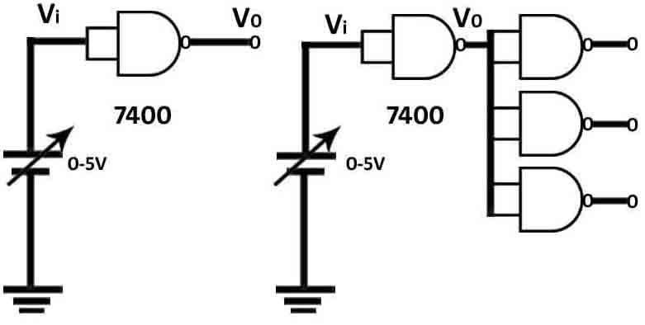

PROCEDURE:
- Insert 74LS, 74HC, and 74 HS any one IC in Socket as given on the trainer board to plot the characteristics.
- Above circuit diagram given for the IC 7400.
- Connect the circuit as shown above.
- Connect the Multimeter to Vi and Connect the Voltmeter to the Vo.
- By varying the input voltage plot a graph between Input and Output.
- Repeat the same procedure for different IC’s.

Voltage Characteristics

  - If using an analog scope, connect the equipment and the component as shown below. If using a digital scope, connect the function generator to channel 1 and the device to channel 2 (opposite of
diagram). Make sure both the function generator and the oscilloscope have the same ground.

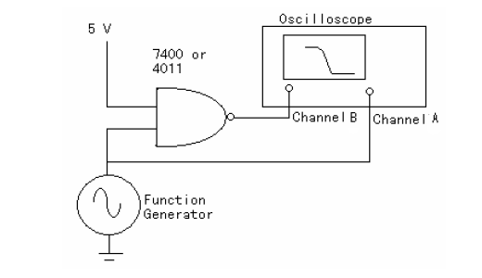

  - For the function generator, select a 0 to 5V sine wave with a frequency of 1 kHz. For the oscilloscope, select the X-Y mode of operation. A trace similar to the one shown below should be obtained. This is called the transfer characteristic of the gate. Note that the input voltage, Vin, is on
the X axis and the output voltage, Vout, on the Y axis.
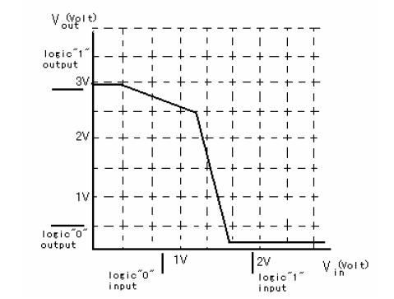

Propagation Delay

- Using two 4011 chips, construct the circuit shown below. Use a chain of 8 gates (n=8) to determine the propagation delay tP. In order to obtain a good measurement of the delay time, a frequency of operation should be chosen sufficiently high so that the total delay in the chain (ntP) is comparable to the period of the input clock. Obtain the delay times tPHL and tPLH from the data sheets. Use
the oscilloscope to measure Vin and Vout. Use a square wave as input.

Why can we not measure both tPHL and tPLH from the circuit shown? [Hint: how many gates do we have and what is the relationship between the input and the output?]
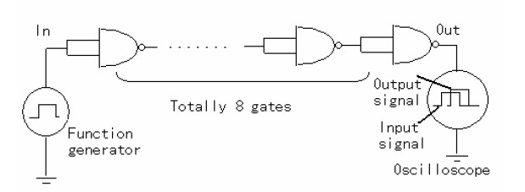

- The propagation delay of a CMOS gate is a function of the load capacitance and the supply voltage VDD. Determine the propagation delay tP as a function of VDD. Use a variable power supply and measure with VDD at 5V, 10V, and 15V.

EXPECTED GRAPH:

RESULT:

The transform characteristics of 74H, LS and HS IC series was plotted .

VIVA QUESTIONS:

- Define propagation delay
- Define rise time.
- What is Boolean Algebra?
- Define a logi-gate. Why is it called so?
- What is positive logic and negative logic?
- Define a truth table.
- Define an analog signal and a digital signal.
- List out the IC’s for various logic operations like NAND, NOR, XOR, OR, AND etc.
- What is De Morgan’s theorem?
- What is the use of De Morgan’s theorem?
- Implement the various logics using the NOR gate.
- Implement the various logic gates using the NAND gate.
- What is an integrated circuit?
- What are the different categories of IC’s?
- What is LS in 74LS IC?
- Which IC’s among 74LS 74HC & HS are static sensitive?
- What is the use of De Morgan’s theorem?
- Implement various logics using NAND gate?
- Implement various logics using NOR gate?
- What is the drawback of IC’s?
- Why are IC’s so cheap?
- Why do IC’s need small power for their operation?
- What are the advantages of IC over discrete components?
- Why are IC’s more reliable?
- What are the important IC technologies used?
- What is a monolithic IC?
- Why is sio2 layer formed over the entire surface in a monolithic IC?
- How is sio2 layer formed in a monolithic IC?
- In IC’s the substrate is not employed as collector why?
- Why is the diffusion technique of formation of resistor most widely used?
- Why is the plastic DIP IC package most widely used?
- With what material are IC’s generally made?
- What is the most popular package of IC?
- What are the elements that cannot be fabricated on IC?
- What are the types of IC’s?
- Write the examples of linear IC’s?
- What are the examples of Digital IC’s?
- Audio amplifier is an example of which IC?
- What are the active and passive elements ?
- What are the active components in IC?
- Is sio2 layer of IC an insulating layer or a resistor ?Explain
- Define propogation delay?
- Define rise time?
- What is Boolean algebra?
- Define logic gate and why is it called so?
- What is positive logic and negative logic?
- Define truth table.
- Define an analog signal and a digital signal?
- List out the IC’s for various operations like NAND NOR XOR AND NOT etc
- What is De Morgan’s theorem?

EXPERIMENT-9
4 BIT GRAY TO BINARY AND BINARY TO GRAY CONVERTER

AIM:
To Convert 4 Bit Gray to Binary and Binary to Gray

APPARATUS:
- 4 Bit Gray to Binary and Binary to Gray Converter Trainer kit.
- Connecting Wires.

THEORY:
Binary-to Gray Converter An interesting application for the exclusive-OR gate is a logic gate to change a binary number to its equivalent in Gray Code. The logic circuit can be used to convert a 4-bit binary number ABCD into its Gray- code equivalent, G1, G2, G3 and G4.As an example, the binary number 0011 will be converted into its Gray- Code equivalent of 0010 by the circuit. Note: A is the most significant bit and D is the least significant bit.
The availability of a large variety of codes for the same discrete elements of information results in the use of different codes by different digital system. It is sometimes necessary to use the output of one system as the input to another. A conversion circuit must be inserted between the two systems if each uses different codes for the same information. Thus, a code converter is a circuit that makes the two systems compatible even though each uses a different binary code. The binary number system is a system that uses only the digits 0 & 1 as codes. To represent a group of 2n distinct element in a binary code requires a minimum of n bits. This is because it is possible to arrange n bits in 2n distinct ways. Although the minimum number of bits required to code 2n distinct quantities is n, there is no maximum number of bits that may be used for binary code. For example, a group of four distinct quantities can be represented by a two bit code, with each quantity assigned one of the following bit combinations: 00, 01, 10, and 11. A group of eight elements requires a three bit code, with each element assigned to one and only one of the following 000, 001, 010, 011, 100, 101, 110, and 111. Gray code (reflected code) .Number in the gray code changes by only one bit as it proceeds from one number to the next. For example in going from decimal 7 to 8, the gray code number changes from 0100 to 1100; these number differ only in MSB. So it is with the entire gray code; every number differs by only one bit from the preceding number. The logic diagram for binary code to gray code converter and gray code to binary code converter.

The logic equations for
Binary to gray code conversion G0 = B0 Å B1
G1 = B1 Å B2 G2 = B2 Å B3 G3 = B3
Gray to binary code conversion B0 = G3 Å G2 Å G1 Å G0
B1 = G3 Å G2 Å G1 B2 = G3 Å G2
B3 = G3

CIRCUIT DIAGRAM:
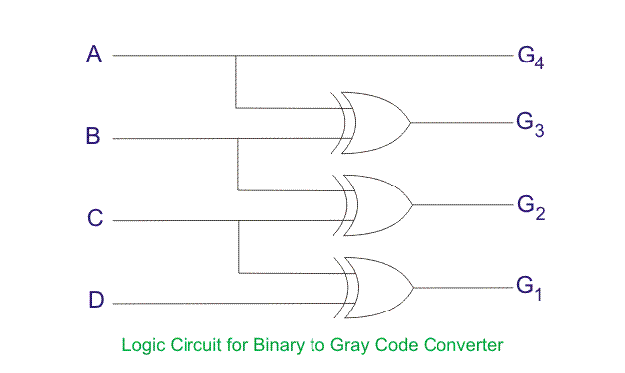

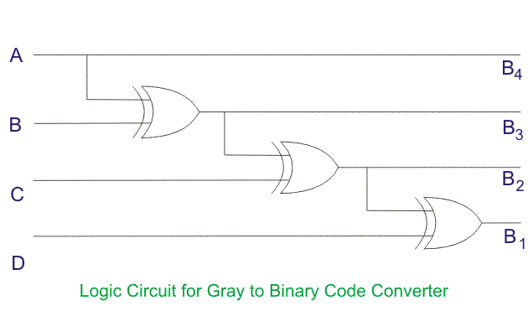

PROCEDURE:

Gray to Binary converter:
- Connect the A, B, C, and D to the Input switches.
- Connect the B4, B3, B2, and B1 to the Output LED’s.
- Verify the Gray to Binary conversion by following truth table.

Binary to Gray converter:
- Connect the A, B, C, and D to the Input switches.
- Connect the G4, G3, G2, and G1 to the Output LED’s.
- Verify the Binary to Gray conversion by following truth table.

TRUTH TABLE:
Binary to Gray conversion:

Decimal Number | 4 Bit Binary Number  ABCD | 4 Bit Gray Code  G1G2G3G4
0 | 0000 | 0000
1 | 0001 | 0001
2 | 0010 | 0011
3 | 0011 | 0010
4 | 0100 | 0110
5 | 0101 | 0111
6 | 0110 | 0101
7 | 0111 | 0100
8 | 1000 | 1100
9 | 1001 | 1101
10 | 1010 | 1111
11 | 1011 | 1110
12 | 1100 | 1010
13 | 1101 | 1011
14 | 1110 | 1001
15 | 1111 | 1000

Gray to Binary to Conversion:

4 Bit Gray Code  ABCD | 4 Bit Binary Code  B4B3B2B1
0000 | 0000
0001 | 0001
0011 | 0010
0010 | 0011
0110 | 0100
0111 | 0101
0101 | 0110
0100 | 0111
1100 | 1000
1101 | 1001
1111 | 1010
1110 | 1011
1010 | 1100
1011 | 1101
1001 | 1110
1000 | 1111

RESULT:

The 4 Bit Gray to Binary and Binary to Gray was converted and the results are verified.

VIVA QUESTIONS:

- What is gray code?
- A code converter is a logic circuit that?
- Reflected binary code is also known as?
- Why do we use gray codes?
- Convert binary number into gray code: 100101
- The primary use for gray code is
- Code is a symbolic representation of?
- Why is the gray code more practical to use when coding the position of a rotating shaft?
- If two numbers are not equal then binary variable will be?
- 74ls85 is a?
- What is a code converter?
- What is the use of gray code?
- What is the code?
- What is the other name for gray code?
- Why is the gray code more practical to use when coding the position of a rotating shaft?
- Why do we use gray codes?
- One way to convert bcd to binary using the hardware approach is?
- Earlier, reflected binary codes were applied to?
- Convert binary number into gray code: 100101
- The binary representation of bcd number 00101001
- Gray code representation of 14 is
- 01001101 represents the letter m in
- How many bits are in a byte?
- Convert hexadecimal value 16 to decimal.
- Are the voltages in digital electronics are continuously variable.
- Which is typically the longest: bit, byte, nibble, word?
- Convert the binary number 1100 to gray code.
- Convert the gray code 1011 to binary.
- What is the difference between binary coding and binary-coded decimal?
- Digital electronics is based on the which numbering system.
- The 1's complement of 10011101 is
- An informational signal that makes use of binary digits is considered to be:
- The binary-coded decimal (bcd) system can be used to represent each of the 10 decimal digits as which code?
- The decimal number 18 is equal to which binary number?
- A code converter is a logic circuit that?
- Reflected binary code is also known as?
- The primary use of gray code is?
- Code is a symbolic representation of?
- If two numbers are not equal then their binary variable will be?
- Ttl74ls85 is a?
- What is the function of an enable input on a multiplexer chip?
- How many outputs are on a bcd decoder?
- What is an encoder?
- What is a decoder?
- In a gray code, each number is 3 greater than the binary representation of that number is it true or false justify?.
- Use the weighting factors to convert the following bcd numbers to binary.
- 0101 0011 0010 0110 1000
- Which digital system translates coded characters into a more useful form?
- How many inputs will a decimal-to-bcd encoder have?
- A principle regarding most ic decoders is that when the correct input is present, the related output will switch:

EXPERIMENT-10
8 BIT PARALLEL LOAD AND SERIAL OUT SHIFT REGISTER USING TWO 4 BIT SHIFT REGISTERS
AIM:
To construct 8 bit parallel load and serial out shift register using two 4 bit shift registers.

APPARATUS:
- 8 bit parallel load and serial out shift register using two 4 bit shift registers trainer kit.
- Patch cords.

THEORY:
The Shift Register is another type of sequential logic circuit that can be used for the storage or the transfer of data in the form of binary numbers. This sequential device loads the data present on its inputs and then moves or shifts it to its output once every clock cycle, hence the name Shift Register.

A shift register basically consists of several single bit D-Type Data Latches͟, one for each data bit either a logic 0 or a 1connected together in a serial type daisy-chain arrangement so that the output from one data latch becomes the input of the next latch and so on.
Data bits may be fed in or out of a shift register serially, that is one after the other from either the left or the right direction, or all together at the same time in a parallel configuration.
The number of individual data latches required to make up a single Shift Register device is usually determined by the number of bits to be stored with the most common being 8-bits (one byte) wide constructed from eight individual data latches.
Shift Registers are used for data storage or for the movement of data and are therefore commonly used inside calculators or computers to store data such as two binary numbers before they are added together, or to convert the data from either a serial to parallel or parallel to serial format. The individual data latches that make up a single shift register are all driven by a common clock ( Clk ) signal making them synchronous devices.
Shift register IC’s are generally provided with a clear or reset connection so that they can be “SET” or RESET͟ as required. Generally, shift registers operate in one of four different modes with the basic movement of data through a shift register being:
- Serial-in to Parallel-out (SIPO) - the register is loaded with serial data, one bit at a time, with the stored data being available at the output in parallel form.
- Serial-in to Serial-out (SISO) - the data is shifted serially “IN͟” and “OUT͟“ of the register, one bit at a
time in either a left or right direction under clock control.
- Parallel-in to Serial-out (PISO) - the parallel data is loaded into the register simultaneously and is shifted out of the register serially one bit at a time under clock control.
- Parallel-in to Parallel-out (PIPO) - the parallel data is loaded simultaneously into the register, and transferred together to their respective outputs by the same clock pulse.
- Shift register converts parallel data, such as an 8-bit data word into serial format, it can be used to multiplex many different input lines into a single serial DATA stream which can be sent directly to a computer or transmitted over a communications line.

PIN CONFIGRATION:
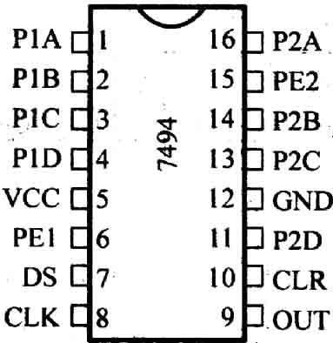
CIRCUIT DIAGRAM:

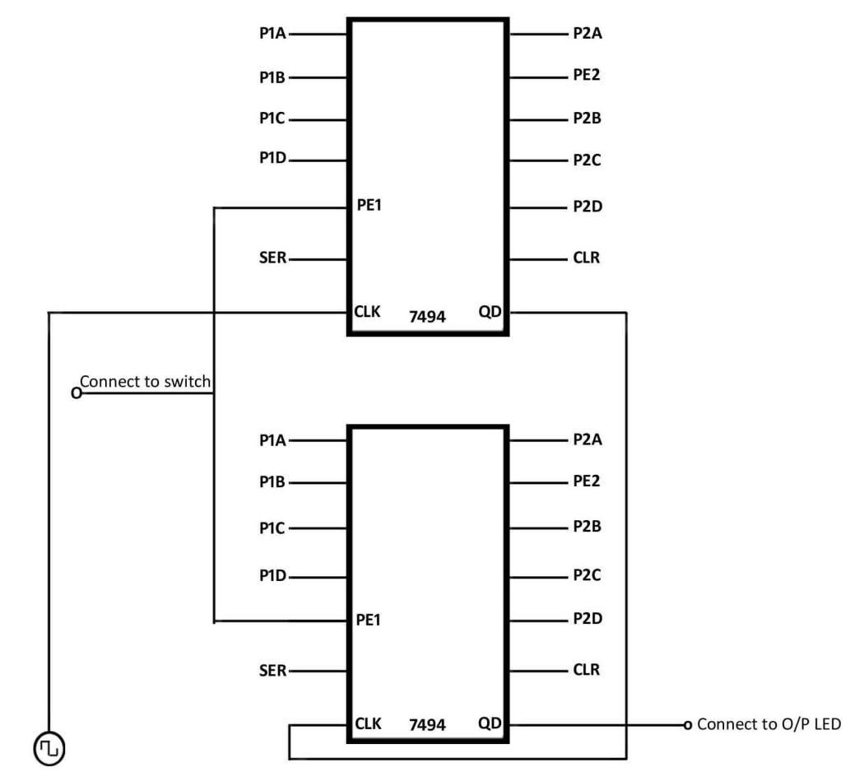

PROCEDURE:
- Connect the circuit as per circuit diagram.
- Connect the CLK to CLK I/P as shown above.
- Connect QD1 to the CLK terminal of another IC.
- Connect the QD2 to the output LED as provided on the trainer board.
- Connect both IC’s PE1 to the input switch as provided on the trainer kit.
- Connect Inputs P1A, P1B, P1C, and P1D to the Input Switches.
- Connect the Outputs to the output LED’s
- Verify the below given truth table.

TRUTH TABLE:

Clock | QA | QB | QC | QD
0 | 0 | 0 | 0 | 0
1 | 1 | 0 | 0 | 0
2 | 0 | 1 | 0 | 0
3 | 0 | 0 | 1 | 0
4 | 0 | 0 | 0 | 1
5 | 0 | 0 | 0 | 0
6 | 1 | 0 | 0 | 0
7 | 0 | 1 | 0 | 0
8 | 0 | 0 | 1 | 0
9 | 0 | 0 | 0 | 1

RESULT:
The 8 bit parallel load and serial out shift register using two 4 bit shift registers was constructed and outputs are verified.

VIVA QUESTIONS

- Define shift registers?
- List the different types of shift registers?
- The full form of SIPO is
- A shift register that will accept a parallel input or a bidirectional serial load and internal shift features is called as?
- What is meant by parallel load of a shift register?
- With a 200 khz clock frequency, eight bits can be serially entered into a shift register in
- Based on how binary information is entered or shifted out, shift registers are classified into categories.
- A serial in/parallel out, 4-bit shift register initially contains all 1s. The data nibble 0111 is waiting to enter. After four clock pulses, the register contains
- A sequence of equally spaced timing pulses may be easily generated by which type of counter circuit
- To operate correctly, starting a ring shift counter requires
- Define shift registers
- List out different types of shift registers.
- The full form of SIPO is
- A shift register that will accept a parallel input or a bidirectional serial load and internal shift features is called as?
- What is meant by parallel load shift registesr?
- With a 200khz clock frequency eight bits can be entered into a shift register in.
- Based on how binary information is entered or shifted out,shift registers are classified into categories.
- A serial in/parallel out 4 bit shift register initially contains all 1’s the data nibble 0111 is waiting to enter.after four clock pulses,the register contains?
- .a sequence of equally spaced timing pulses may be easily generated by which type of counter circuit?
- To operate correctly,starting a ring shift counter requires.
- Explain the difference between serial digital data and parallel digital data
- What is the definition of a register in the context of digital circuitry? Also, define and compare/contrast what a shift register is.
- Draw the schematic diagram for a five-bit serial-in/serial-out shift register circuit, and be prepared to give a brief explanation of how it functions.
- Explain how a shift register circuit could be built from D-type flip-flops with the ability to shift data either to the right or to the left, on command.
- Explain what a universal shift register is
- Describe how we can get parallel data entered into a shift register circuit.
- A shift register that will accept a parallel input or a bidirectional serial load and internal shift features is called as?
- How can parallel data be taken out of a shift register simultaneously?
- What is meant by parallel load of a shift register?
- The group of bits 11001 is serially shifted (right-most bit first) into a 5-bit parallel output shift register with an initial state 01110. After three clock pulses, the register contains?
- Assume that a 4-bit serial in/serial out shift register is initially clear. We wish to store the nibble 1100. What will be the 4-bit pattern after the second clock pulse?
- An 8-bit serial in/serial out shift register is used with a clock frequency of 2 mhz to achieve a time delay (td) of
- On the fifth clock pulse, a 4-bit Johnson sequence is Q₀ = 0, Q₁ = 1, Q₂ = 1, and Q₃ = 1. On the sixth clock pulse, the sequence is ________.
- The bit sequence 0010 is serially entered (right-most bit first) into a 4-bit parallel out shift register that is initially clear. What are the Q outputs after two clock pulses?
- On the third clock pulse, a 4-bit Johnson sequence is Q₀ = 1, Q₁ = 1, Q₂ = 1, and Q₃ = 0. On the fourth clock pulse, the sequence is ________.
- A bidirectional 4-bit shift register is storing the nibble 1101. Its input is HIGH. The nibble 1011 is waiting to be entered on the serial data-input line. After three clock pulses, the shift register is storing ________.
- What does the output enable do on the 74395A chip?
- In a 6-bit Johnson counter sequence there are a total of how many states, or bit patterns?
- A modulus-12 ring counter requires a minimum of how many flipflops?
- Stepper motors have become popular in digital automation systems because they are driven by ---------- signals and have repetitive__________ moment.
- A sequence of equally spaced timing pulses may be easily generated by which type of counter circuit?
- The bit sequence 10011100 is serially entered (right-most bit first) into an 8-bit parallel out shift register that is initially clear. What are the Q outputs after four clock pulses?
- If an 8-bit ring counter has an initial state 10111110, what is the state after the fourth clock pulse?
- How would a latch circuit be used in a microprocessor system?
- A 4-bit shift register that receives 4 bits of parallel data will shift to the ________ by ________ position(s) for each clock pulse.
- How many clock pulses will be required to completely load serially a 5-bit shift register?
- An 8-bit serial in/serial out shift register is used with a clock frequency of 150 khz. What is the time delay between the serial input and the Q₃ output?
- What are the three output conditions of a three-state buffer?
- The primary purpose of a three-state buffer is?
- What is the difference between a ring shift counter and a Johnson shift counter?

EXPERIMENT-11
RING COUNTER & TWISTED RING COUNTER USING 4 BIT SHIFT REGISTER
AIM:
To Construct a Ring Counter and Twisted Ring Counter using 4 Bit Shift Register.

APPARATUS:
- Ring Counter and Twisted Ring Counter using ϰBit Shift Register Trainer kit.
- Patch Cords.

THEORY:
Ring counter is a basic register with direct feedback such that the contents of the register simply circulate around the register when the clock is running. Here the last output that is QD in a shift register is connected back to the serial input. A basic ring counter can be slightly modified to produce another type of shift register counter called Johnson counter. Here complement of last output is connected back to the not gate input and not gate output is connected back to serial input. A four bit Johnson counter gives 8 state output.

PIN CONFIGURATION:
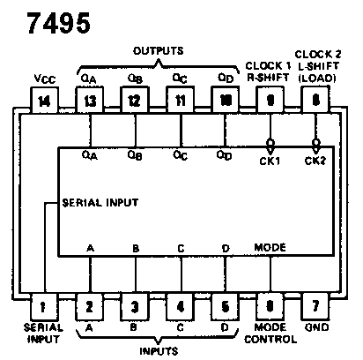
CIRCUIT DIAGRAM:

Ring Counter:
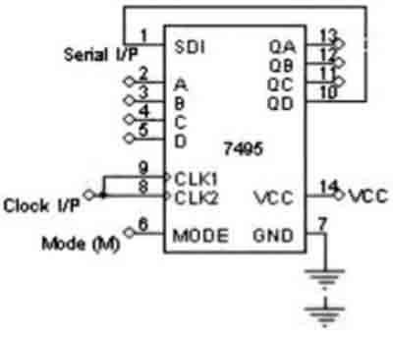

Twisted Ring Counter:

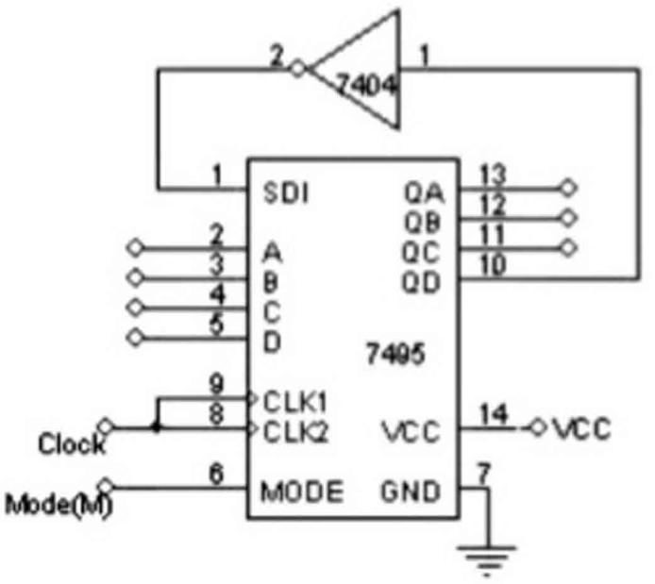

PROCEDURE:

Ring Counter:

- Make the Connection as show in the Ring Counter Circuit Diagram.
- Connect Inputs A, B, C, D to input switch present on trainer kit.
- Connect the Outputs QA, QB, QC, QD
- Connect the Serial I/P to Pin 10 of the 7495 IC i.e., QD
- Connect 8th and 9th Pin’s of the IC 7ϰ9ϱ to Clock, which is present on the trainer.
- Connect Mode(M) 6th Pin of IC 7495 to Input Switch
- Verify the truth table of Ring counter.

Twisted Ring Counter:
- Make the Connection as show in the Twisted Ring Counter Circuit Diagram.
- Connect Inputs A, B, C, D to input switch present on trainer kit.
- Connect the Outputs QA, QB, QC, QD
- Connect the Serial I/P to NOT Gate, which is present on trainer kit
- Connect other terminal of the NOT Gate to Pin 10 of the 7495 IC i.e., QD
- Connect 8th and 9th Pin’s of the IC 7ϰ9ϱ to Clock, which is present on the trainer.
- Connect Mode(M) 6th Pin of IC 7495 to Input Switch
- Verify the truth table of Twisted Ring counter

TRUTH TABLE:

Ring Counter:
Set the Mode to High and Low condition for reset.

Clock | QA | QB | QC | QD
0 | 1 | 0 | 0 | 0
1 | 0 | 1 | 0 | 0
2 | 0 | 0 | 1 | 0
3 | 0 | 0 | 0 | 1
4 | 1 | 0 | 0 | 0
5 | 0 | 1 | 0 | 0
6 | 0 | 0 | 1 | 0
7 | 0 | 0 | 0 | 1
8 | 1 | 0 | 0 | 0

Twisted Ring Counter:

Clock | QA | QB | QC | QD
0 | 0 | 0 | 0 | 0
1 | 1 | 0 | 0 | 0
2 | 1 | 1 | 0 | 0
3 | 1 | 1 | 1 | 0
4 | 1 | 1 | 1 | 1
5 | 0 | 1 | 1 | 1
6 | 0 | 0 | 1 | 1
7 | 0 | 0 | 0 | 1
8 | 0 | 0 | 0 | 0

Results

A Ring Counter and Twisted Ring Counter using 4 Bit Shift Register was constructed and implemented.

VIVA QUESTIONS
- Define Ring counter?
- By adding recirculation lines to a 4-bit parallel-in serial-out shift register, it becomes a ________, ________, and ________out register.
- What type of register would have a complete binary number shifted in one bit at a time and have all the stored bits shifted out one at a time?
- When is it important to use a three-state buffer?
- A bidirectional 4-bit shift register is storing the nibble 1110. Its input is LOW. The nibble 0111 is waiting to be entered on the serial data-input line. After two clock pulses, the shift register is storing ________
- In a parallel in/parallel out shift register, D0 = 1, D1 = 1, D2 = 1, and D3 = 0. After three clock pulses, the data outputs are ________
- The group of bits 10110111 is serially shifted (right-most bit first) into an 8-bit parallel output shift register with an initial state 11110000. After two clock pulses, the register contains
- What type of register would have a complete binary number shifted in one bit at a time and have all the stored bits shifted out one at a time?
- In a 4-bit Johnson counter sequence there are a total of how many states, or bit patterns?
- If a 10-bit ring counter has an initial state 1101000000, what is the state after the second clock pulse?
- How much storage capacity does each stage in a shift register represent?
- Ring shift and Johnson counters are-----------
- What is the difference between a shift-right register and a shift-left register?
- What is a transceiver circuit?
- A 74HC195 4-bit parallel access shift register can be used for……………….operation
- Which type of device may be used to interface a parallel data format with external equipment’s serial format?
- What is the function of a buffer circuit?
- What is the preset condition for a ring shift counter?
- Which is not characteristic of a shift register?
- To keep output data accurate, 4-bit series-in, parallel-out shift registers employ a------------
- Another way to connect devices to a shared data bus is to use a……………
- A down counter using n-flip-flops count……………….
- UP Counter is…………………
- DOWN counter is…………………
- How many different states does a 3-bit asynchronous down counter have?....................
- In a down counter, which flip-flop doesn’t toggle when the inverted output of the preceeding flip-flop goes from HIGH to LOW.
- In a 3-bit asynchronous down counter, the initial content is
- In a 3-bit asynchronous down counter, at the first negative transition of the clock, the counter content becomes
- In a 3-bit asynchronous down counter, at the first negative transition of the clock, the counter content becomes
- The hexadecimal equivalent of 15,536 is ________
- Define static RAM
- Define dynamic RAM
- Classify types of ROMs
- Applications of ROMS
- What is the difference between latch& Flip-Flop, Explain with logic diagram.
- Explain any one application of SR latch.
- What is race around condition? how it is avoided?
- How synchronous counters differ from asynchronous counters?
- List counter applications.
- State various applications of counters.
- Difference between Asynchronous clock and Synchronous Clock
- Draw the truth table of SR and JK
- Draw the Excitation Table of SR and JK
- Give the Excitation Table of D and T Flip Flop
- What is meant of Edge Triggering
- Types Of Shift Registers.
- Specify the operations done on Shift Registers
- Explain the decade counter
- Draw the Logic diagram for Conversion of D-SR
- List the Counter Types

EXPERIMENT-12
4 DIGITS HEX COUNTER USING SYNCHRONOUS ONE DIGIT HEX COUNTERS

AIM:
To Construct a 4 Digit Hex Counter using 1Digit synchronous Hex counter.

APPARATUS:
- Digit Hex counter using 1 Digit Synchronous Hex counter.
- Patch Cords

THEORY:
When working with large digital systems, such as computers, it is common to find binary numbers consisting of 8, 16 and even 32 digits which makes it difficult to both read and write without producing errors especially when working with lots of 16 or 32-bit binary numbers.
One common way of overcoming this problem is to arrange the binary numbers into groups or sets of four bits (4-bits). These groups of 4-bits uses another type of numbering system also commonly used in computer and digital systems called Hexadecimal Numbers.
The hexadecimal or simply HEX numbering system uses the Base of 16 system and are a popular choice for representing long binary values because their format is quite compact and much easier to understand compared to the long binary strings of I’s and o’s.
Being a Base-16 system, the hexadecimal numbering system therefore uses 16 (sixteen) different digits with a combination of numbers from 0 through to 15. In other words, there are 16 possible digit symbols.
However, there is a potential problem with using this method of digit notation caused by the fact that the decimal numerals of 10, 11, 12, 13, 14 and 15 are normally written using two adjacent symbols. For example, if we write 10 in hexadecimal, do we mean the decimal number ten, or the binary number of two (1 + 0). To get around this tricky problem hexadecimal numbers that identify the values of ten, eleven, . . . , fifteen are replaced with capital letters of A, B, C, D, E and F respectively.
Then in the Hexadecimal Numbering System we use the numbers from 0 to 9 and the capital letters A to F to represent its Binary or Decimal number equivalent, starting with the least significant digit at the right hand side.
As we have just said, binary strings can be quite long and difficult to read, but we can make life easier by splitting these large binary numbers up into even groups to make them much easier to write down and understand. For example, the following group of binary digits 1101 0101 1100 11112 are much easier to read and understand than 11010101110011112 when they are all bunched up together.
In the everyday use of the decimal numbering systems we use groups of three digit or 000’s from the right hand side to make a very large number such as a million or trillion, easier for us to understand and the same is also true in digital systems.
Hexadecimal Numbers is a more complex system than using just binary or decimal and is mainly used when dealing with computers and memory address locations. By dividing a binary number up into groups of 4 bits,each group are set of 4 digits can now have a possible value of between “ 0000”(0) and “1111” ( 8+4+2+1 = 15 ) giving a total of 16different number combinations from 0 to 15,Don’t forget that “0” is also a valid digit.
We remember from our first tutorial about Binary Numbers that a 4-digit group of digits is called a “nibble” and as 4-bits are also required to produce a hexadecimal number, a hex digit can also be thought of as a nibble, or half-a-byte. Then two hexadecimal numbers are required to produce one full byte ranging from 00 to FF.

Also, since 16 in the decimal system is the fourth power of 2 ( or 24 ), there is a direct relationship between the numbers 2 and 16 so one hex digit has a value equal to four binary digits so now q is equal to”16”.
Because of this relationship, four digits in a binary number can be represented with a single hexadecimal digit. This makes conversion between binary and hexadecimal numbers very easy, and hexadecimal can be used to write large binary numbers with much fewer digits.
The numbers 0 to 9 are still used as in the original decimal system, but the numbers from 10 to 15 are now represented by capital letters of the alphabet from A to F inclusive and the relationship between decimal, binary and hexadecimal is given below.

PIN CONFIGRATION:

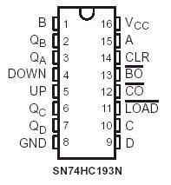
CIRCUIT DIAGRAM:

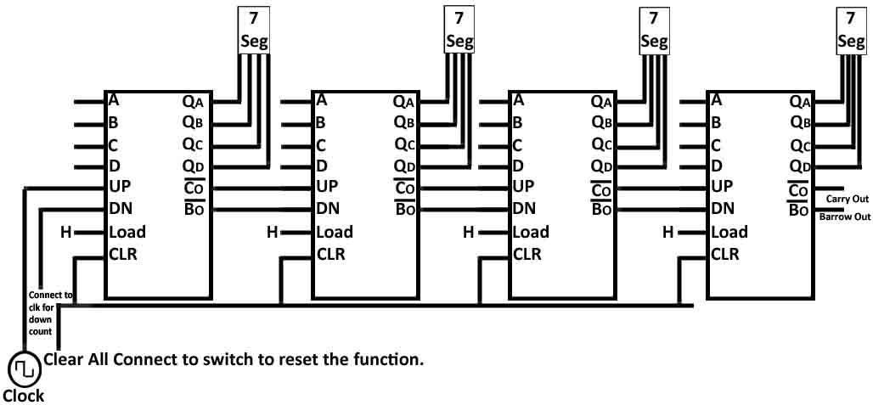

PROCEDURE:
- Connect the circuit as shown in circuit diagram.
- Connect UP of IC 74193 to Clock I /P.
- Connect Clear I/P’s and connect to inputs switch, which are present on the trainer kit.
- Connect QA, QB, QC, and QD of all IC’s to the 7 segment display.
- Connect Carry out of IC 74193 to UP terminal of other IC 74193 as shown in the circuit diagram.
- Observe Output according to the truth table.

TRUTH TABLE:

Decimal Number | 4-bit Binary Number | Hexadecimal Number
0 | 0000 | 0
1 | 0001 | 1
2 | 0010 | 2
3 | 0011 | 3
4 | 0100 | 4
5 | 0101 | 5
6 | 0110 | 6
7 | 0111 | 7
8 | 1000 | 8
9 | 1001 | 9
10 | 1010 | A
11 | 1011 | B
12 | 1100 | C
13 | 1101 | D
14 | 1110 | E
15 | 1111 | F
16 | 0001 0000 | 10 (1+0)
17 | 0001 0001 | 11 (1+1)
Continuing upwards in groups of four

RESULT:
The 4 Digit Hex Counter using 1Digit synchronous Hex counter was designed and implemented.

VIVA QUESTIONS:
- State various applications of counters.
- Difference between Asynchronous clock and Synchronous Clock
- Draw the truth table of SR and JK
- Draw the Excitation Table of SR and JK
- Give the Excitation Table of D and T Flip Flop
- What is meant of Edge Triggering
- Types Of Shift Registers.
- Specify the operations done on Shift Registers
- Explain the decade counter
- Draw the Logic diagram for Conversion
- A MOD-12 and a MOD-10 counter are cascaded. Determine the output frequency if the input clock frequency is 60 MHz
- Which segments of a seven-segment display would be required to be active to display the decimal digit 2?
- How many AND gates would be required to completely decode ALL the states of a MOD-64 counter, and how many inputs must each AND gate have?
- A BCD counter is a ________.
- How many flip-flops are required to construct a decade counter?
- The terminal count of a typical modulus-10 binary counter is ________
- A seven-segment, common-anode LED display is designed for:………
- How many flip-flops are required to make a MOD-32 binary counter?
- Using four cascaded counters with a total of 16 bits, how many states must be deleted to achieve a modulus of 50,000?
- A MOD-16 ripple counter is holding the count 1001₂. What will the count be after 31 clock pulses?
- The terminal count of a modulus-11 binary counter is ________.
- List which pins need to be connected together on a 7493 to make a MOD-12 counter.
- How can a digital one-shot be implemented using HDL?
- Integrated-circuit counter chips are used in numerous applications including:…………
- Synchronous construction reduces the delay time of a counter to the delay of:
- Synchronous counters eliminate the delay problems encountered with asynchronous counters because the:
- What is the difference between combinational logic and sequential logic?
- What is the difference between a 7490 and a 7492?
- When two counters are cascaded, the overall MOD number is equal to the ________ of their individual MOD numbers.
- A MOD-12 and a MOD-10 counter are cascaded. Determine the output frequency if the input clock frequency is 60 MHz
- Which segments of a seven-segment display would be required to be active to display the decimal digit 2?
- How many AND gates would be required to completely decode ALL the states of a MOD-64 counter, and how many inputs must each AND gate have?
- A BCD counter is a ________.
- How many flip-flops are required to construct a decade counter?
- The terminal count of a typical modulus-10 binary counter is ________.
- A seven-segment, common-anode LED display is designed for:………
- Which of the following is an invalid output state for an 8421 BCD counter?
- How many different states does a 3-bit asynchronous counter have?
- A 5-bit asynchronous binary counter is made up of five flip-flops, each with a 12 ns propagation delay. The total propagation delay (t_{p(tot)}) is ________.
- One of the major drawbacks to the use of asynchronous counters is:------------------
- Once an up-/down-counter begins its count sequence, it cannot be reversed.(True/False)…………..
- Three cascaded modulus-5 counters have an overall modulus of ________.
- An asynchronous 4-bit binary down counter changes from count 2 to count 3. How many transitional states are required?

- How many different states does a 3-bit asynchronous counter have?
- A 5-bit asynchronous binary counter is made up of five flip-flops, each with a 12 ns propagation delay. The total propagation delay (t_{p(tot)}) is ________.
- One of the major drawbacks to the use of asynchronous counters is:------------------
- Once an up-/down-counter begins its count sequence, it cannot be reversed.(True/False)…………..
- Three cascaded modulus-5 counters have an overall modulus of ________.
- An asynchronous 4-bit binary down
- The final output of a modulus-8 counter occurs one time for every ________.

. EXPERIMENT-13
4 DIGITS HEX COUNTER USING ASYNCHRONOUS ONE DIGIT COUNTER

AIM:
To construct and study Hex counter using Asynchronous one digit Hex counter.

APPARATUS:
- 4 Digit Hex counter using Asynchronous one digit Hex counter.
- Patch Cords.

THEORY:
When working with large digital systems, such as computers, it is common to find binary numbers consisting of 8, 16 and even 32 digits which makes it difficult to both read or write without producing errors especially when working with lots of 16 or 32-bit binary numbers.
One common way of overcoming this problem is to arrange the binary numbers into groups or sets of four bits (4-bits). These groups of 4-bits uses another type of numbering system also commonly used in computer and digital systems called Hexadecimal Numbers.
The hexa decimal or simply HEX numbering system uses the Base of 16 system and are a popular choice for representing long binary values because their format is quite compact and much easier to understand compared to the long binary strings of 1’s and 0’s.
The Hexadecimal, or Hex, numbering system is commonly used in computer and digital systems to reduce large strings of binary numbers into sets of four digits for us to easily understand. The word Hexa decimal means sixteen because this type of digital numbering system uses 16 different digits from 0-to-9, and A-to-F.
To convert binary numbers into hexadecimal numbers we must first divide the binary number up into a 4-bit binary word which can have any value from 010 ( 00002 ) to 1510 ( 11112 ) representing the hexadecimal equivalent of 0 through to F.

PIN CONFIGRATION:

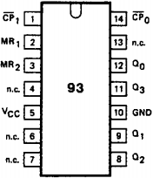

CIRCUIT DAIGRAM:

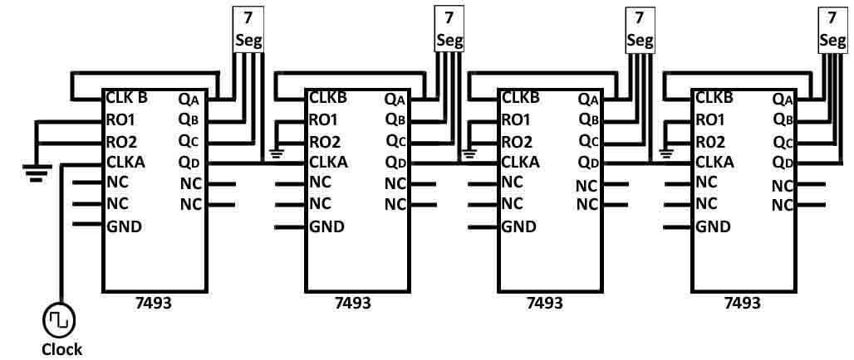
PROCEDURE:
  - Connect the circuit as show in the circuit diagram.
  - Connect CLKB to the QA.
  - Connect RO1 and RO2 Ground.
  - Connect Clock to CLKA.
  - Connect QD to CLKA of another IC as shown in the circuit diagram.
  - Connect QA, QB, QC, and QD to the 7 segment displays.
  - Observe and verify the truth table as given below.

TRUTH TABLE:

Decimal Number | 4-bit Binary Number | Hexadecimal Number
0 | 0000 | 0
1 | 0001 | 1
2 | 0010 | 2
3 | 0011 | 3
4 | 0100 | 4
5 | 0101 | 5
6 | 0110 | 6
7 | 0111 | 7
8 | 1000 | 8
9 | 1001 | 9
10 | 1010 | A
11 | 1011 | B
12 | 1100 | C
13 | 1101 | D
14 | 1110 | E
15 | 1111 | F
16 | 0001 0000 | 10 (1+0)
17 | 0001 0001 | 11 (1+1)

RESULT:
Thus the Hex counter using Asynchronous one digit Hex counter was constructed and studied.

VIVA QUESTIONS:

- A MOD-12 and a MOD-10 counter are cascaded. Determine the output frequency if the input clock frequency is 60 MHz
- Which segments of a seven-segment display would be required to be active to display the decimal digit 2?
- How many AND gates would be required to completely decode ALL the states of a MOD-64 counter, and how many inputs must each AND gate have?
- A BCD counter is a ________.
- How many flip-flops are required to construct a decade counter?
- The terminal count of a typical modulus-10 binary counter is ________.

- A seven-segment, common-anode LED display is designed for:………

- To operate correctly, starting a ring counter requires………………..

- For a multistage counter to be truly synchronous, the ________ of each stage must be connected to ________.

- Which of the following is an invalid output state for an 8421 BCD counter?
- How many different states does a 3-bit asynchronous counter have?
- A 5-bit asynchronous binary counter is made up of five flip-flops, each with a 12 ns propagation delay. The total propagation delay (t_{p(tot)}) is ________.
- One of the major drawbacks to the use of asynchronous counters is:------------------
- Once an up-/down-counter begins its count sequence, it cannot be reversed.(True/False)…………..
- Three cascaded modulus-5 counters have an overall modulus of ________.

- An asynchronous 4-bit binary down counter changes from count 2 to count 3. How many transitional states are required?
- The final output of a modulus-8 counter occurs one time for every ________.

- A 4-bit up/down binary counter is in the DOWN mode and in the 1100 state. To what state does the counter go on the next clock pulse?
- A counter with a modulus of 16 acts as a ________.
- A 4-bit ripple counter consists of flip-flops, which each have a propagation delay from clock to Q output of 15 ns. For the counter to recycle from 1111 to 0000, it takes a total of ________.
- The terminal count of a 3-bit binary counter in the DOWN mode is ________.
- In an HDL ring counter, many invalid states are included in the programming by:---------------
- Three cascaded decade counters will divide the input frequency by ________.
- In a VHDL retriggerable edge-triggered one-shot, which condition will not exist when a clock edge occurs
- Which of the following is an invalid output state for an 8421 BCD counter?
- counter changes from count 2 to count 3. How many transitional states are required?
- The final output of a modulus-8 counter occurs one time for every ________.
- How can a digital one-shot be implemented using HDL?
- Integrated-circuit counter chips are used in numerous applications including:…………
- Synchronous construction reduces the delay time of a counter to the delay of:
- Synchronous counters eliminate the delay problems encountered with asynchronous counters because the:
- What is the difference between combinational logic and sequential logic?
- What is the difference between a 7490 and a 7492?
- When two counters are cascaded, the overall MOD number is equal to the ________ of their individual MOD numbers.
- A MOD-12 and a MOD-10 counter are cascaded. Determine the output frequency if the input clock frequency is 60 MHz
- Which segments of a seven-segment display would be required to be active to display the decimal digit 2?
- How many AND gates would be required to completely decode ALL the states of a MOD-64 counter, and how many inputs must each AND gate have?
- A BCD counter is a ________.
- The terminal count of a modulus-11 binary counter is ________.
- List which pins need to be connected together on a 7493 to make a MOD-12 counter.
- How many flip-flops are required to construct a decade counter?
- The terminal count of a typical modulus-10 binary counter is ________.
- A seven-segment, common-anode LED display is designed for:………
- To operate correctly, starting a ring counter requires………………..

- How many flip-flops are required to make a MOD-32 binary counter?Using four cascaded counters with a total of 16 bits, how many states must be deleted to achieve a modulus of 50,000?
- A MOD-16 ripple counter is holding the count 1001₂. What will the count be after 31 clock pulses?
- What is race around condition? how it is avoided?
- How synchronous counters differ from asynchronous counters?
- List counter applications.
- State various applications of counters.

